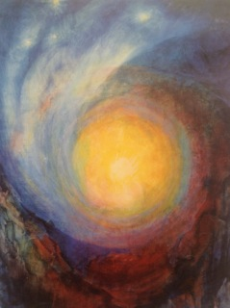
Midwinter Festival
Rudolf Steiner Centre
This Sunday, 28th June
ALL WELCOME

Midwinter Verse 38 from Rudolf Steiner’s Calendar of the Soul

38 Holy Night Mood

I feel, enchantment-freed,
The spirit child in womb of soul:
Within the brightness of the heart,
The holy World Word has begotten
The heaven-fruit of hope
Which grows, rejoicing, worlds afar,
From out my being’s ground divine.

Ninetta Sombart – Birth
3:00 pm Reading: Gabriel Imagination from the Four Seasons and the Archangels by Rudolf Steiner, with John Jackson
4:30 pm Painting session: for the midwinter, with Sonya Lethbridge
- There will be a soup for those who want to stay afterwards

6:30 pm Social gathering over refreshements in the Foyer – please bring a plate to share

7:00 pm Festival Celebration in the Festival Room

It used to be in Autumn time that the Easter Festival was held, Rudolf Steiner tells us. It is when we can see the resurrection forces in the autumn colours of nature. Michael – who is like God – gives us the courage to recognise the counter forces in us : we ‘fight against the dragon’ and gain a new consciousness that allows the inner light to shine in the Midwinter.
We can now come to be at peace inwardly: Gabriel – who is God’s Strength - helps us to come to ourselves in a new way, after the storm and commotion in nature. The Earth and the elemental world are at peace, and the Christ light can shine inside each human being.
This inner light rays out and can create new social warmth and love.
In our festival this year we will recite St Paul’s Corithians 13 again, which Rudolf Steiner translated for us to learn from, showing how love in its deepest significance can become the essence in all we do, feel, think and speak.

After John Jackson’s welcome, Robyn Hewetson will speak a winter poem;
Matthew Frear will lead us in singing the Holy Night Round of Julian’s 52 Souls Calendar Rounds, together.
The chorus will speak Corinthians 13,
Johnny Ryan will take us on an inner journey in his festival address.
We will sing the round again together
The chorus will present Soloviev’s Immanuel – God with us, showing how the all-powerful divine is always with us, helping us to realise that we are co-responsible for the future evolution of humanity, if we can step into that inner strength.

Festival preparation: Astrid and John.

