Musings on Arithmetic 2026

Contents
Musings on Arithmetic 1 3
Willing, Feeling, Thinking 3
Musings 2 NL14 5
Number Recognition 5
Musings 3 NL15 6
Picturing Numbers 6
Musings 4 - NL16 9
Number Scripts 9
Musings 5 - NL17 10
Addition & Subtraction 10
Musings 6 - NL18 12
Number Sets and Negativity 12
Musings 7 - NL19 14
Negativity 14
Musings 9 – NL23 15
Aliquot Parts 15
Musings 10 – NL22 16
Perfect Numbers 16
Musings 12 – NL24 17
Introducing Arithmetic’s Little Helpers imaginatively: 17
Musings 13 – NL27 19
Odds and Evens - Pythagoras 19
Musings 14 – NL25 23
Visual proofs of the Pythagorean Right Triangle Theorem 23
Musings 15 – NL28 27
Even Numbers and time - musical harmonic frequencies. 27
Musings 16 – NL29 34
Metamorphosis in the Waldorf Maths Curriculum reflects the growth of children. 34
Musings 17 – NL30 38
Growth by multiplication. 38
Musings 18 – NL34 41

Musings on Arithmetic 1

Willing, Feeling, Thinking
Arithmetic can be seen as an entry into Mathematics
Mathematics is the science and study of quality, structure, space, and change by seeking out patterns and formulating new conjectures, from the Greek ‘manthanein’ to learn. One could say: Mathematics is an intelligent human response to the discovery of the wonders of existence.
At first, as a child, the world, over which the sun shines, appears to us as an outer Oneness.
We next differentiate PARTS of existence from their background, so they become separate. This requires discrimination (a process called analysis).
Once the parts are separated in our mind, we can count them, acknowledge them.
Arithmetic is the ‘art of counting’ from the Greek ‘arithmos’ number.
Numbers are not things – they are ‘ideas’. So Arithmetic is, essentially, a thinking activity – a ‘spiritual’ science. Most children encounter this early in their schooling.
The three soul forces of willing, feeling and thinking are involved:
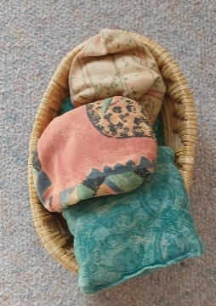
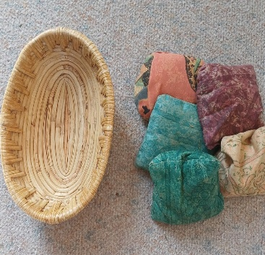
- Willing. When counting objects of a similar nature, say apples (or in a classroom, maybe, ‘beanbags’) in a basket. One first perceives a unity, a ‘basket’. On analysis – an important activity for a school child – the basket is seen to contain many apples. How many? Let’s count! Now the activity: grasp an apple … put it on the table, and say “one” … take a second apple … put on the table beside the first one, and say “two” … and so on until no apples are left in the basket and a new pile has been formed on the table (synthesis). The will activities incurred have been ‘grasp’, ‘put’, ‘say’.
Full Empty
- Feeling in this situation is connected with the relationships between ‘things’ or ‘beings’, namely between the ‘numbers’ in the sequence which we learn by rote (like poetry) for counting, ‘one, two, three, four, five …’ We get to know that ‘one’ comes first; that ‘four’ comes after ‘three’ but before ‘five’. Every language, a child of feeling, has its own set of Counting Numbers. We know the numbers ‘by heart’.
- Thinking is a more reflective process. Here it is concerned with the essential character of each number. ‘One’ is all alone, I, it is lonely, so it needs to be strong and resolute. In one sense, the whole world is ‘one’.
‘Two’ has a partner – they can stand side by side: II, as a pair, wings on a bird or butterfly. Left and right hand (eye, ear, foot, etc.). But they can also form a polarity, such as father-mother; day-night; sun-moon; up-down; forwards-backwards; window-wall; sky-earth. Can you think of more?
‘Three’ can be more complex. When three stand side by side, III, one is in the middle, with the ends being a polarity: mother-child-father; left-centre-right, Or three, 3, can form a tripod of equals, as the three legs of a stool. They may form a sequence: dawn-day-dusk.
‘Four’ is the number of legs that cat, dog, cow and chair have. Wheels on a car. Directions: north, east, south, west. Earth, water, air, fire.
And so on with larger numbers – children love discovering ‘numbers’ inherent or hidden in their environment.
*************************
Many things connected with maths can be seen in the light of the three soul forces engaged in the early years:
- Will: creating and working with patterns and form; counting objects – determining quantity. Writing numbers; number operations [adding, subtracting, multiplying, dividing, etc.]; calculations. Involving action, change.
- Feeling: rhythm and rhyme, counting sequence, relationships [equations: equals =, larger >, smaller < than]; ordinal numbers – rank, position [first, second, etc.]. Involving judgment.
- Thinking: the essence of number, symbols, concepts, cognition; qualitative aspects. Involving imagination, picturing.
With the names for numbers used in various European languages, it is interesting to see their similarity; perhaps the interchangeability T and D and Z when spoken.
# | English | Latin | French | German | Spanish | Greek
1 | One | Unus | Un | Eins | Uno | Ena (Ένα)
2 | Two | Duo | Deux | Zwei | Dos | Dyo (Δύο)
3 | Three | Tres | Trois | Drei | Tres | Tria (Τρία)
4 | Four | Quattuor | Quatre | Vier | Cuatro | Tessera (Τέσσερα)
5 | Five | Quinque | Cinq | Fünf | Cinco | Pente (Πέντε)
6 | Six | Sex | Six | Sechs | Seis | Hexa (Έξι)
7 | Seven | Septem | Sept | Sieben | Siete | Hepta (Επτά)
8 | Eight | Octo | Huit | Acht | Ocho | Octo (Οκτώ)
9 | Nine | Novem | Neuf | Neun | Nueve | Ennea (Εννέα)
10 | Ten | Decem | Dix | Zehn | Diez | Deca (Δέκα)
They are all based on ten - the number of digits on our two hands. Also, 10=1+2+3+4 (sum of the first four numbers). It is interesting that 7 (a prime number) is used in counting time: 7 days in a week - based on the 7 heavenly lights that move across the firmament of the stars [Sun, Moon, Mercury, Venus, Mars. Jupiter, Saturn.] A human lifetime is loosely divided into 7-year epochs until the age of 63.
There are 13 weeks in a season and 4 seasons in a year, but then there are 12 months in a year. A dozen [12] is used in packing things, like eggs. Day and night each have 12 hours! 12 is an abundant number as it has many [4] factors: 12=2x6=3x4, while ten is a 'poor' number - it has only two: 10=2x5.
The ancient Sumerian civilisation had a base of 60. The legacy of that is 1 hour = 60 minutes [minute means small]; and 1 minute = 60 seconds [ the hour was 'first']
Anyway, ten has been universally adopted by the modern world as the base for counting. 100=10x10; 1,000 = 10x10x10 and so on.
A more esoteric reason may be that ten has been considered of the Earth because of the four natural realms Mineral. Plant, Animal, Human as shown in this diagram where 1+2+3+4=10
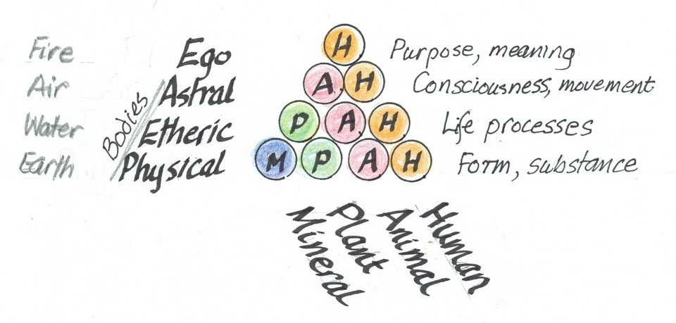
When doing Arithmetic, writing the full name is rather laborious; we need a quicker system of making marks, or in some other way to keep track, to represent the number. Historically, it has been quite a journey to arrive at the symbols used so widely today. Let's explore:
What patterns can be made out of each number of small items - in a classroom a selection of florist's coloured glass pebbles. Here are some - note the relation between Even and Odd - what do you see?
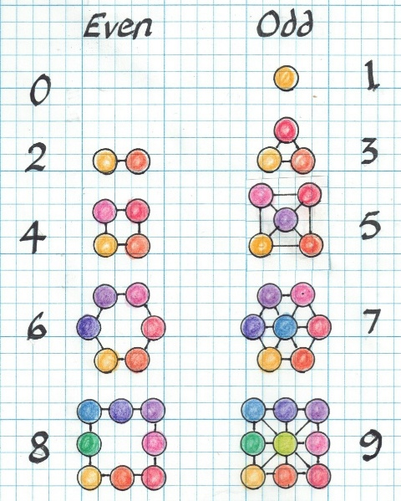
Some more next week.
Robin

Musings 2 NL14

Number Recognition
See = Number Recognition pptx

Musings 3 NL15

Picturing Numbers
•Counting out loud is verbal and momentary and not visual.
•Often, we want to show a number visually or tactilely using our hands.
•For small numbers, we can count on the fingers of both hands.
•If each digit (finger or thumb) represents ‘one’ 1, we can get up to 10.
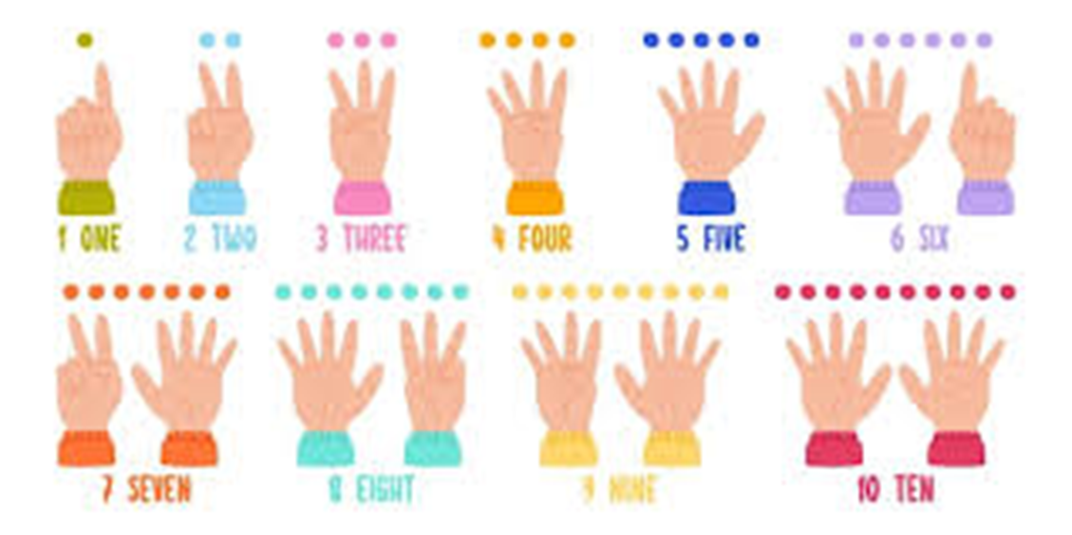
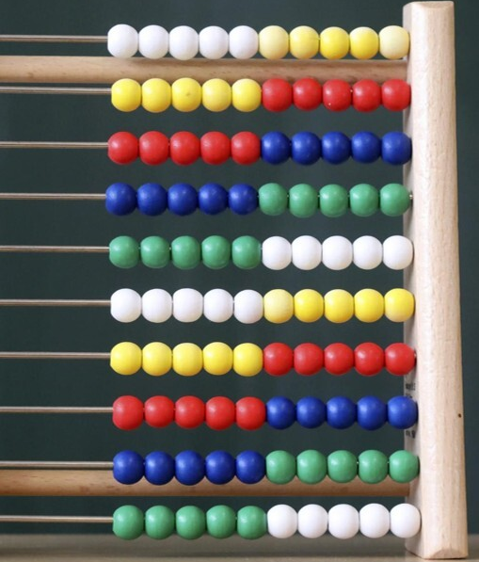
Below is an Abacus with 100 beads arranged on ten slide wires with 10 beads on each sliders.
It can be used to represent numbers - leaving your hands free - and to perform simple calculations, such as adding and subtracting:
•The Japanese Soroban abacus has a central “value” bar with four slider beads below and one above.
•You only count the sliders against the central value bar.
•The one pictured below can show all the numbers up to a quintillion, using powers of 10.
•It can be used for the four basic Arithmetic operations: +, -, x, /
For children it gives an excellent 'hands on' experience of numbers and calculation.

The visible part of the soroban represents the number 1,234,567,890, each column indicating one digit, with the lower beads representing "ones" and the upper beads "fives".
•The soroban is still taught in some Japanese primary schools as a way to visualize and grapple with mathematical concepts.
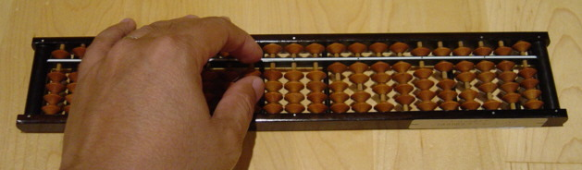
•The practice of soroban includes the teacher reciting a string of numbers (addition, subtraction, multiplication, and division) in a song-like manner where at the end, the answer is given by the teacher.
•This helps train the ability to follow the tempo given by the teacher while remaining calm and accurate.
•In this way, it reflects on a fundamental aspect of Japanese culture of practicing meditative repetition in every aspect of life.
The numbers are visible but not written.
Using our hands like this is not very convenient when we need our hands for other things, then we need to find another way, such as making marks on something like a tablet or a sheet of paper. Numerals have been derived from counting upwards from one:
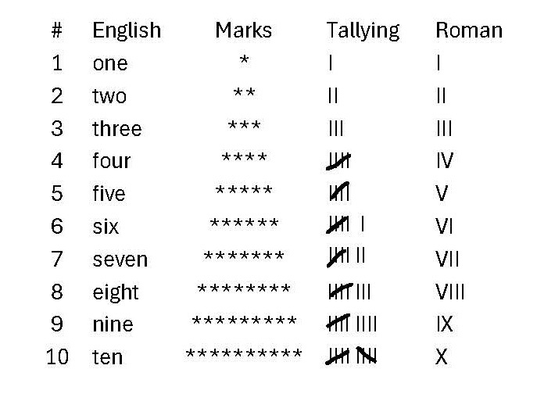
Each row shows the symbol from the previous row with a mark added.
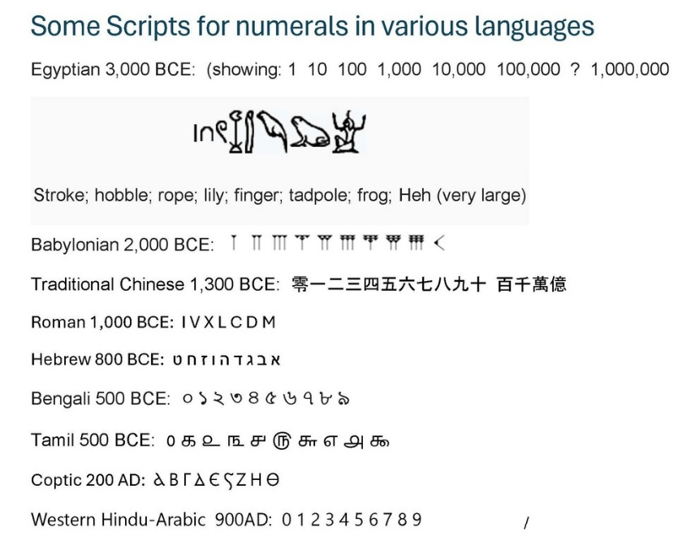
Each column shows symbols becoming more condensed.
Note how the Tallying result for 5 looks like a hand with the thumb laid across the fingers, which becomes the V of Roman numerals. Then the two Vs become X (one up and the other down!)
However, the later Roman numerals introduce a new element: If a smaller symbol is placed after a larger symbol (VI = 5+1 = 6), it is added;
But if it is placed in front (IV = 5-1 = 4), it is subtracted, so position becomes important.
•The Roman system is similar to the Japanese Soroban using decimal multiplies of 1 and 5, but did not go to very large numbers. 100 was Centum, 1,000 was Mille.
I=1, V=5, X=10, L=50, C=100, D=500, M=1,000.
•There was no zero because no-one found it useful to count nothing.
•Larger numbers were later written by using a vinculum, that is a bar written over a number to multiply it by 1,000; a double bar by 1,000,000. So 5,000 is V ̅, and 10,000 is X ̅ (sorry, this symbol won't show properly on this editor)
The Hindu-Arabic numeric system, (that includes zero, 0), which is used worldwide today, was introduced only in the 10th century AD, which is relatively recent historically.
The above plus some more is shown in a PowerPoint: Arithmetic 3 Number Representation

Musings 4 - NL16

Number Scripts
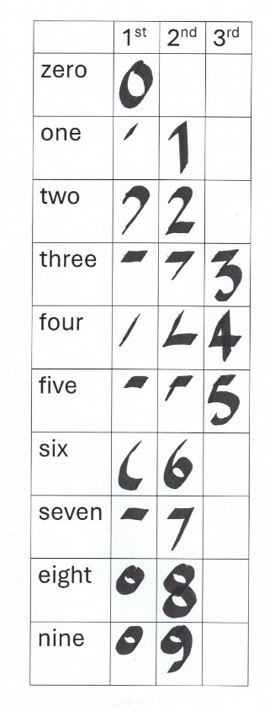
On the Soroban the numbers are visible but not written. Numbers are universal IDEAS which invokes our spiritual activity to understand them. Writing brings numbers into the physical world, and supports our memory for large numbers or complex calculations and helps when we wish to communicate with another person - or with a computer/calculator!
In earlier cultural ages, every language had its own set of numerals, often so different as to be unrecognisable.
The Hindu-Arabic numeric system, (that includes zero, 0), which is used worldwide today, was introduced only in the 10th century AD, which is relatively recent historically.
A criterion for symbols is that they must be easy and quick to write, with as few strokes as possible - this table shows that is true for our modern symbols:

On the other hand, they are best being quite distinct from each other, and not easily confused with one another or letters of the alphabet. So, strangely 6 and 9 are very similar - one being a rotation of the other (For people with dyslexia, that can be a problem.). As well as that, when we compare scripts for the numerals with those for the alphabet, we get a close similarity between the vowel, O, and the numeral for zero, 0; and between the vowel, I, and the numeral for one, 1, and the lower case l (L). These five symbols as seen in 6 computer fonts
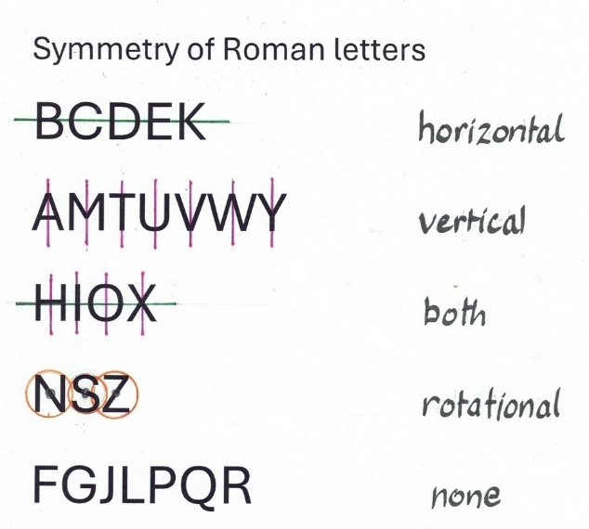
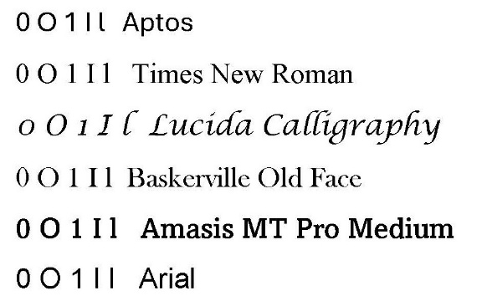
There is a polarity between the circular O and the straight I, which is used in the On/Off symbol Φ
where O = Off and I = On. The binary counting system - the basis of computer programming - simply uses just one, I and zero, 0.
Somewhat related is the high degree of symmetry of the Roman capital letters (uncial [written in the same-sized box] majascules).
~~~

Musings 5 - NL17

Addition & Subtraction
- Combination & Separation
- Expansion & Contraction
- Inhalation & Exhalation
The mental activity involved in Arithmetic can be considered a 'spiritual activity' and is thus a very important part of anyone's education.
Arithmetic Operations [Will]
•The result of the operation of addition [+ "plus"] (combining, gathering) is the SUM.
•The result of the operation of subtraction [- "minus"] (separation, dispersing) is the DIFFERENCE.
•The result of the operation of multiplication [ x or * "times"] (stacking) is the PRODUCT.
•The result of the operation of division [/ or ÷ "divided by"] (splitting) is the QUOTIENT [or Quota]
This activity is often shown in the form of an equation with a equals sign =.
= signifies a balance where what is on the left has the same value as what is on the right of it.
For example: ten is equal to nine plus one: 10 = 9 + 1
Number Bonds
The base of our number system is ten, 10. It is called the Decimal System. Decimal means based on ten.
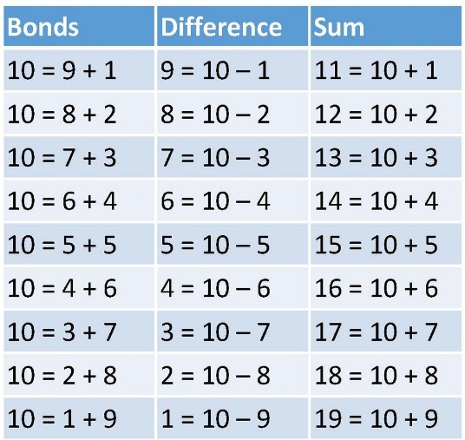
So, it is useful to know these relationships "by heart":
An Equation is a Story
•The simplest folk or fairy story has 3 elements:
1.An initial situation, a beginning, the scene is set’
2.The protagonist or main character, leaves home, goes on an adventure and carries out some action.
3.The protagonist returns home or settles, transformed as a result of the adventure.
•An arithmetical equation depicts a story, also with 3 elements:
- An initial situation, a position on a ‘number line’;
- The adventure is an arithmetical operation (action);
- The result is the homecoming.
Helen left a plum tree with 20 plums;
On the way home she met James and gave him 7 plums for his family;
When Helen arrived home she had 13 plums.
When reduced to numbers the essence of this story becomes:
20 - 7 = 13
A decimal number chart - - rather than a number line
A number line listing all numbers in order can be very long and the larger numbers soon get lost to sight.
When we write – in English [and other European languages] we start at the TOP LEFT of the page and write horizontally to the RIGHT.
When we come to the right edge we ‘fold’ the line and continue it BELOW the first line,
and continue DOWN the page to the BOTTOM.
(there is quite a number of other languages, e.g. traditional Mandarin,
that write vertically, or from right to left) •We can also fold the number line: - after 9 start a new line below with 10, and so on – up to 99.
•Each decade has its own horizontal line.
•Each vertical column has the same units figure.
•To be complete, we need to start from ‘zero’. 0

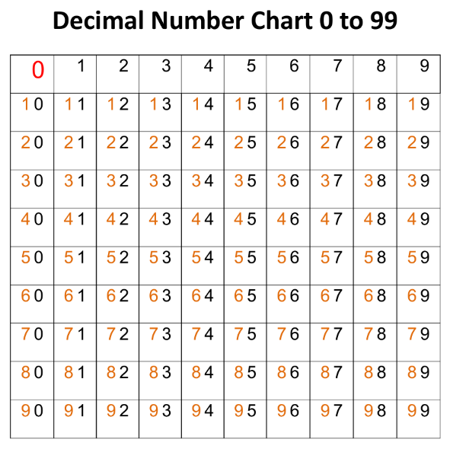
We could continue with a second chart behind this one (3rd dimension) with the nombers 100 to 199; then another with the numbers 200 to 299; and so on...
Addition & Subtraction operations shown on the Chart
The value of such a chart in the classroom is that it makes the processes of addition and subtraction VISIBLE.
We have a starting position, an action or movement, coming to a final position or result.
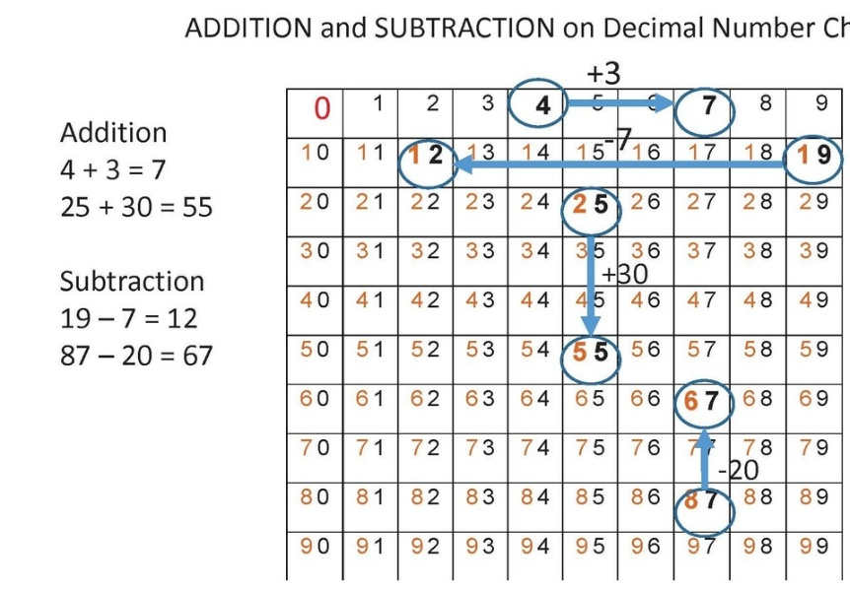
•When we add a number under 10 we move to the Right:
•E.g. 4+3. start at 4 and move 3 positions to the Right to a final position 7.
•When we subtract a number under 10 we move to the Left:
•E.g. 19-7. start at 19 and move 7 positions to Left to 12.
•When we add a number multiple of 10 we move Down to the rows below:
•E.g. 25+30. start at 25 and move down 3 rows to 55.
•When we subtract a multiple of 10 we move Up to the rows above:
•E.g. 87-20. start at 87 and move up 2 rows to 67.
Notice the difference between position (static) and movement (active)
Here you can visualise the above:

Using larger numbers:
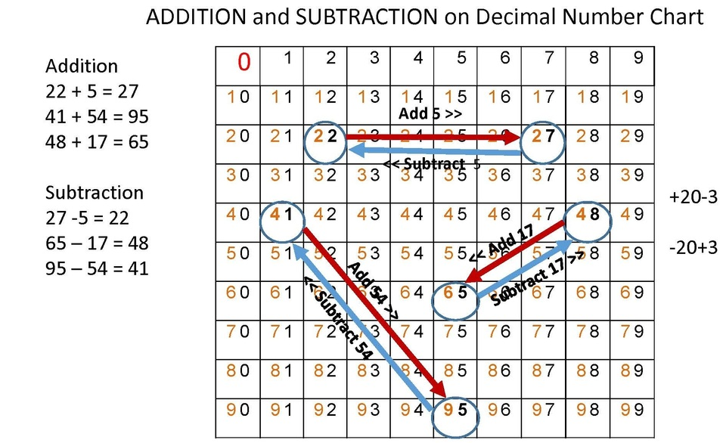
~~~~.

Musings 6 - NL18

Number Sets and Negativity
For millennia, numbers were just “counting numbers” which today we call the SET of Natural Numbers (ℕ)
A set of Natural numbers (or counting numbers) includes all positive numbers without fractions or decimals that start from 1 and continue indefinitely { …} – without end.
In mathematical symbols: ℕ = {1, 2, 3, 4, …}
Counting up is a form of expansion – getting bigger and bigger, unlimited.
Counting down is a form of contraction – getting smaller and smaller – but not without end. We come to a threshold, a limit, when we get down to 1, we cannot go any further, we have run out of numbers.
To break through this threshold we have to be creative, to create a new number – that is zero, 0, the empty basket, nothingness! You might say, in very early times people did not see any point in counting nothing, that is something that wasn’t there. However, mathematicians and philosophers did ponder these things: “And the earth was without form, and void.” It was just an idea in the mind of the Creator God, not yet manifest physically.
Here are some ways that early civilisations represented the idea of “nothingness”, an empty gap between:
I wonder if the Mayan symbol represents a closed eye – when our eyes are closed we see nothing!
Anyway, the acceptance of zero leads to a new, greater set of numbers, namely:
Whole Numbers (��)
A set of Whole numbers consists of all natural numbers, including 0.
That is: �� = {0, 1, 2, 3, 4, …}
If ‘nothing’ is a problem for people to accept, then ‘less than nothing’ is going to be much harder to accept.
If you have a basket of apples and you have given away all the apples that you have in the basket, how can you give away any more? …give away what you don’t have?
You could, however, give a promise! A promise of future action. Such a promise, your word, is an obligation, like a debt!
When you have something, it is a fortune, an asset; when you have promised something to someone, it is an obligation, a debt to be taken from what you may acquire in the future.
It is an interesting gesture – to give away what you do not yet have. Is that Generosity, Foolishness, or Fraud?
Let us explore the polarity warm <> cool further:
Add, plus, acquiring, selfishness <<< >>> Subtract, minus, giving, altruism.
Words are often coloured with feelings - these related polar words reflect that in a different way:
Asset Debt
Positive Negative
Good Bad, evil
Where can we experience “less than nothing” in daily life?
With money! Money is an idea, a belief.
I believe that the currency, the notes and coins in my purse have value – that they are tokens for value. We are continually making equations, comparisons: The value of an object (that I wish to purchase) to me compared to the value of the monetary token to me.
Only when they are equal (or better) will I make a purchase.
Value of object = Value of money.
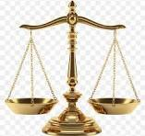
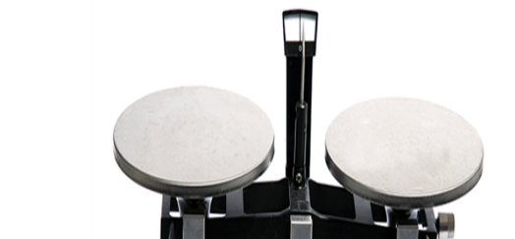
This ‘equals’ symbol =, comes from the Scales [the 7th sign of the zodiac is Libra – Scales; Hips in the human body – keeping balance as we walk] or the mechanical Balance we use for weighing things, that is comparing an object’s weight with standard weights – pounds and ounces, or kilograms and grams. (In England, for many years the same word, ‘pound’, was used to name a unit of weight and a unit of money!)
The derivation of comparison symbols:
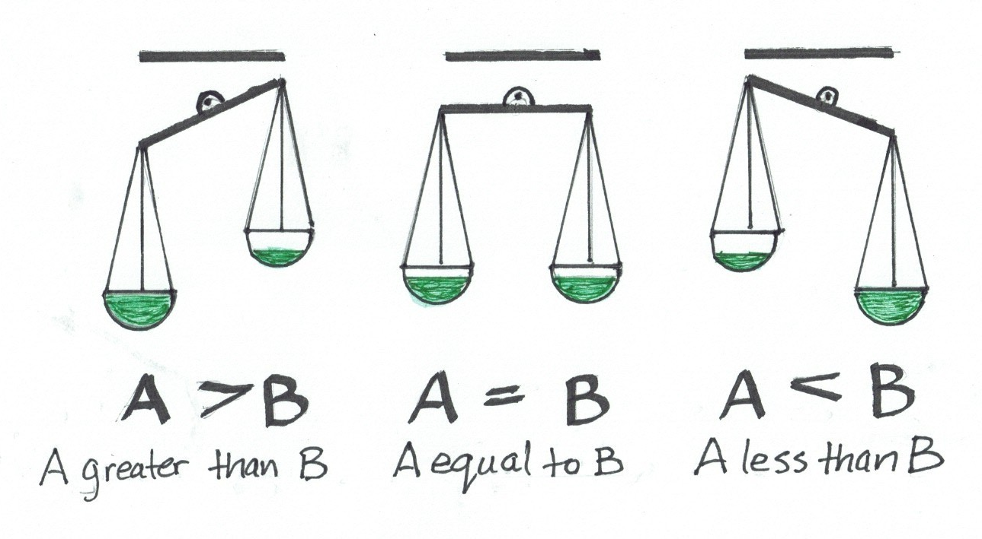
7 > 5, so the difference is positive: 7 - 5 = 2
7 < 9, so the difference is negative: 7 - 9 = -2, a number below zero, 0.
Unfortunately the same symbol, -, is often used for both the operation of subtraction and the position of a number below zero. This can lead to confusion - more about this in a future musing.
Where else is the idea of ‘negative’ numbers used, at least partially?
In historical time - for dates before a key event, such as the birth of Jesus Christ [BC] [but note there is no Year 0 between BC and AD or CE].
In a building: positive numbers for the floor levels above ground; negative for the basement floors below ground level.
So we come to the next set of numbers:
Integers (ℤ)
A set of integers includes all positive and negative natural numbers and zero.
Example
ℤ = {…, -4, -3, -2, -1, 0, 1, 2, 3, 4, …}

Musings 7 - NL19

Negativity
There have been several ways of indicating negative numbers.
•Most common is the minus or hyphen sign in front of a digit. -45
•Sometimes used is an elevated hyphen in front of a number. ¯ 83 to differentiate it from the minus subtraction operator.
•A third way, used in Vedic mathematics and in logarithms, is a bar over the digit. This makes just this digit negative, not the whole number. 5 ̅
Thus 72 ̅ = 68 (i.e. 70 – 2)
Because the word processor used to create this newsletter cannot create 'bar' numbers properly but puts the bar after the number [as seen above] not over the top like a hat as required, I have placed the content of this week's Musing in a .pdf of a PowerPoint where they appear properly.
Even with MSWord creating a bar number is quite a long process -- try it to create "bar 5":
- Click 'Insert';
- Click 'Equation';
- Click 'Accent';
- Find the 10th option, called 'Bar';
- Click 'Bar';
- Click in box under the bar that appears;
- type 5.

Musings 9 – NL23

Aliquot Parts
Last week we looked at Division of one number (the Dividend) by another (the Divisor) to get a quotient (or share).
This week we consider those occasions where there is no remainder, where the Divisor and Quotient are FACTORS [things are made in factories] of the Dividend. Sometimes, all the factors of a number are called its Aliquot parts. This excludes the number itself, (being the whole, not a part). It, of course, divides just once into itself, so 1 is an Aliquot part.
This was studied by Euclid (325 BC - 265 BC) a famous Greek mathematician best known for his treatise on geometry: The Elements, which influenced the development of Western mathematics for more than 2,000 years.
Aliquot means "some" or "so many". It is a compound of two Latin terms:
alius: meaning "other" or "some"
quot: meaning "how many" or "as many"
Euclid discovered 4 categories of numbers: Prime; Deficient; Perfect; Abundant
Prime means first (best). A Primes only Aliquot part is 1.
The remainder (Deficient, Perfect, and Abundant) are Composite numbers having a set of Prime Factors.
For example, the Prime Factors of 210 are {2, 3, 5, 7}
Other than 1, their Aliquot parts come in pairs that multiply together to make the number.
The Aliquot Parts of 210 are {1, 2, 3, 5, 6, 7, 10, 14, 15, 21, 30, 35, 42, 70, 105}
Deficient (or Poor) numbers have only a few factors or paired Aliquot parts that when added together, the sum is less than the number itself.
On the other hand, Abundant (or Rich) numbers have many factors or Aliquot parts that when added together, the sum is more than the number itself.
Perfect numbers are on the boundary, the threshold, between the Deficient and the Abundant numbers - their Aliquot parts that, when added together, sum exactly equal to the number itself. Perfect numbers are few and far between. Before the advent of electronic computers, less than a dozen had been discovered.
In the chart below we look at the first 32 numbers, and we can see how very different they are – like a class of children with different qualities, character and temperaments. The Abundant numbers are like sanguines with many friends. The Primes are strong and independent – they are the building blocks or factors making the others, the composite numbers.
Look at the chart and see what other patterns and relationships you can find.
The four perfect numbers 6, 28, 496 and 8128 seem to have been known from ancient times and there is no record of these discoveries.
6 = 1 + 2 + 3,
28 = 1 + 2 + 4 + 7 + 14,
496 = 1 + 2 + 4 + 8 + 16 + 31 + 62 + 124 + 248
8128 = 1 + 2 + 4 + 8 + 16 + 32 + 64 + 127 + 254 + 508 + 1016 + 2032 + 4064
Notice how the numbers double except for the pair near the middle - the second number is one less than double the first one, and in each case the second of the pair is a prime number. Mysteries abound!
RB
~~~

Musings 10 – NL22

Perfect Numbers
The first four perfect numbers 6, 28, 496 and 8128 seem to have been known from ancient times - there is no historical record of their discovery.
1st. 6 = 1 + [2 + 3],
2nd. 28 = 1 + 2 + [4 + 7] + 14,
3rd. 496 = 1 + 2 + 4 + 8 + [16 + 31] + 62 + 124 + 248
4th. 8128 = 1 + 2 + 4 + 8 + 16 + 32 + [64 + 127] + 254 + 508 + 1016 + 2032 + 4064
Notice how the numbers are double the preceding number in the sequence, except for the pair near the middle - the second number is one less than double the first one - in algebra this is n and 2n-1.
In each case the second of the pair is a prime number. The powers of 2 [2¹, 2², 2³, ...] or [2, 4, 8, ...] are very important.
Here is a chart showing the calculations for the first seven perfect numbers. As you can see they grow very fast, and are quickly few and far between. The seventh perfect number is already greater than a hundred billion. It would take a lifetime to count as far as this!
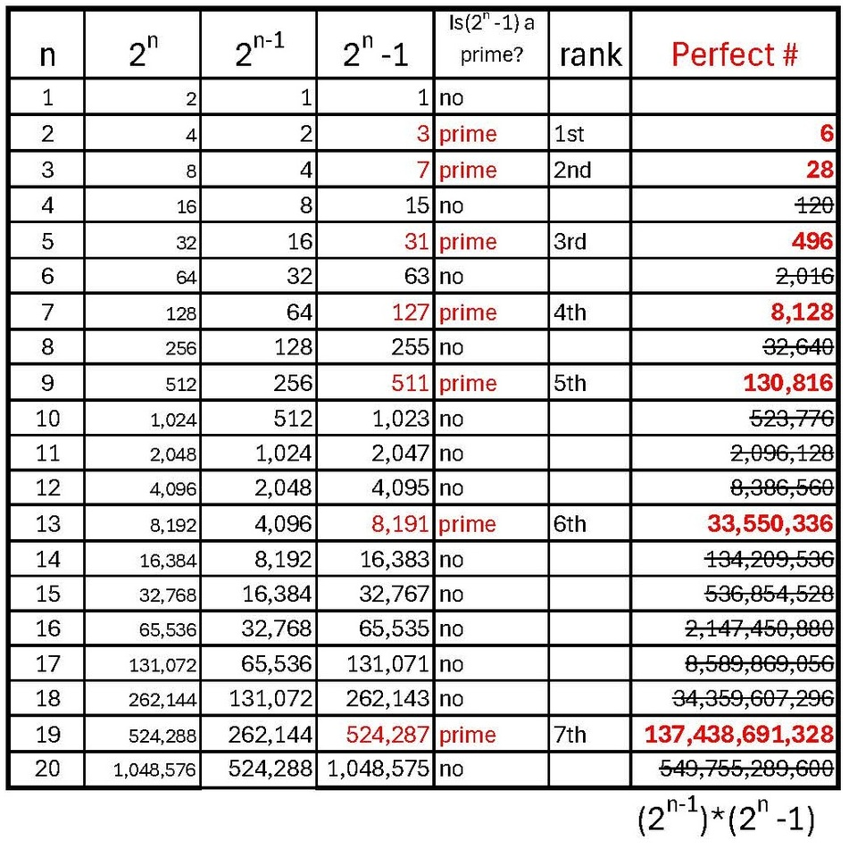
RB
~~~

Musings 12 – NL24

Introducing Arithmetic’s Little Helpers imaginatively:
ADDITION: The activity of gathering and collecting things together is the process of addition for which we use the symbol + called plus. Result: Sum
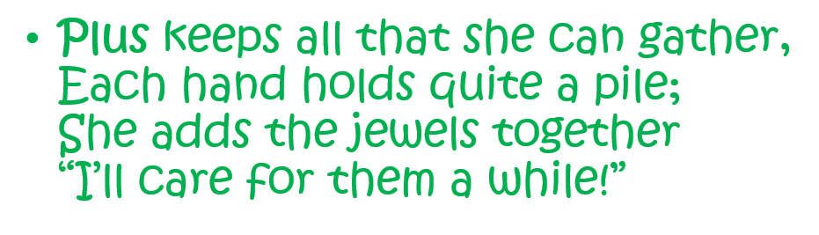
SUBTRACTION: The activity of sharing or giving things to others is the process of subtraction for which we use the symbol – called minus. Result: Difference
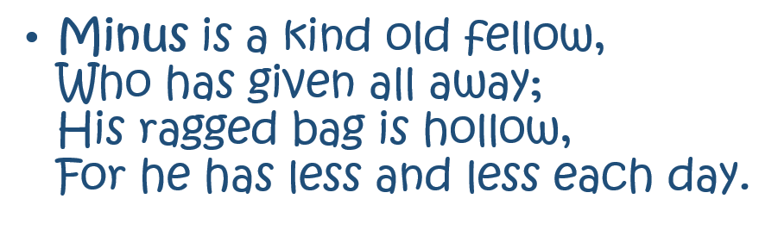
MULTIPLICATION: The activity of gathering and stacking equal-sized blocks of things together for which we use the symbol x, called times. Result: Product.
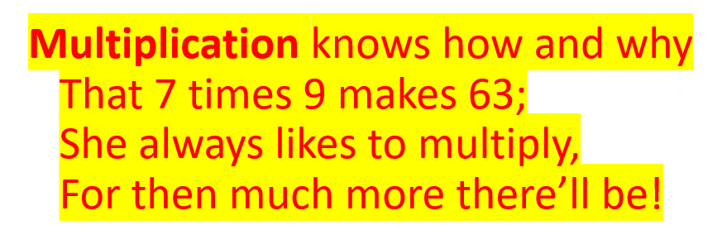
DIVISION: The activity of sharing and distributing things into exact equal-sized groups for which we use the symbols / or ÷ or : called divide by. Result: Quotient or Quota
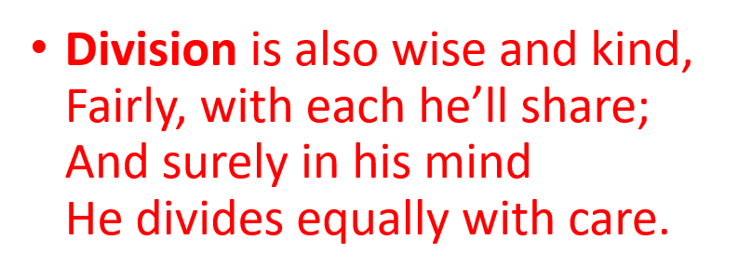
COMPARISON: Greater than’ 'Equal' ‘Less than’
The Hungry Alligator < = >
The Hungry Alligator always turns towards the bigger side:

Big > Small or Small < Big;
But when both sides are the same, he just smiles:
Same = Same
So 7>5; 7<9; but 7+7 = 9+5
More next week. RB
~~~~

Musings 13 – NL27

Odds and Evens - Pythagoras
Over the next few weeks, I would like to look at the simple idea of odds and evens that fascinated the famous Greek philosopher Pythagoras (570 to 495 BC), who related them to 'space' and 'time'.
The name Pythagoras originates from Pythios (a name for the god Apollo) and agora (meaning "marketplace" or "assembly"). Together, the name translates roughly to "spoken by the Pythian [Apollo]" or "oracle of the marketplace," honouring the god Apollo, associated with wisdom and prophecy.
Apollo and Dionysus are complementary half-brothers in Greek mythology.
Apollo, god of the sun, prophecy, and music, represents structure, self-control, the conscious mind, reason, logic, and harmony;
Dionysus, god of theatre, wine, ritual madness (as the lack of conformity of the newly developing EGO was perceived). He represents raw emotion, instinct, and the unconscious mind, embodying passion, ecstasy, and chaos.
Rather than rivals, the ancient Greeks viewed them as essential counterparts whose energies balanced one another, particularly in the arts and at the oracle of Delphi.
First, let us look at ODD numbers.
1 1 1+0
3 1 + 1 + 1 1+2
5 2 + 1 + 2 1+4
7 3 + 1 + 3 1+6
9 4 + 1 + 4 1+8
and so on.
In the diagram below, first lay pebbles in a straight line with the 'unpaired one' in the middle.
Next bend the line (with the unpaired one in the middle) at right-angles, so they form a series of squares.
A line has length, but a square has area.
One of the great geometrical insights of Pythagoras was about right-angled triangles.
Triangles, as the name indicates, have 3 angles between adjacent sides; but they have 3 points (or vertices) and 3 lines (or sides). 3x3 = 3² = 9.
Angles can be measured as a portion of a full turn. A turn can be divided into much finer portions: 360° [degrees].
The 360° came from Astronomy when the year was seen as the return of the sun to the same place in the zodiac in just over 360 days. Actually 365.24 days - that is 360 days with an extra 5.24 days. In ancient Mesopotamia [the flat land between the River Tigris and the River Euphrates, capital Babylon] they had a Administrative Year of 12 months of 30 days, so each time a new year started, the start moved in relation to the Solar year and the agricultural seasons! The next year would thus start about 5 days earlier. This mounted up so that after a 70 year cycle it would a full year early! 70 [3 score years and ten] was considered the length of a human lifetime - how fitting!
In due course the calendar became close to a solar year of 12 months of 30 days (= 360 days) by adding a 5 day pause before the next year began. [another small problem: the time from one full moon to the next is only 29.5 days, not 30!! So 12 moonths made a Lunar year of 354 days) The 5 days added to the end of the Admin year, before the Solar new year could begin, were used to create a Holy New Year festival. So they came to be known as Holidays. As you can see 360 is nearly midway between the lunar 354 days and the solar 365.24 days - a good compromise.
Later, this arrangement was changed and the holidays were distributed through the year, so the odd-numbered months January, March, May, July*, etc. got an extra day (holiday), making that month 31 in total. To do this properly they needed 6 days but only had 5, so 1 day was taken from February so it had only 29! Perhaps they were just trying to make winter shorter? What we can notice is: 'Nothing fits mechanically!' Our solar system is not a machine!
(* July and August are named by Julius Caesar and Augustus Caesar. The high summer month of August, being the 8th [not an odd number] month, only had 30 days until Caesar decreed that it also would have 31, thus altering the sequence for the following months - now both October and December getting 31 days - so another day had to be 'stolen' from February.)
Anyway, based on this, we still use 360° for a full turn, so 180° for a half turn, and 90° for a quarter turn - the corner of a regular square, and 60° for the corner of a regular triangle, a 1/6th turn.
So what was it that Pythagoras noticed?
That all 3 internal angles of every triangle always summed to 180°, the same as only 2 angles (or half) of a square.
That is: if one angle of a triangle was a right angle (90°) then the other two angles together must have the same value of 90°.
Now the remarkable discovery was that at the same time if squares were constructed on the sides of this triangle, then the area of the square on the longest side (called the hypotenuse) – opposite the right-angle in the triangle – was equal to the areas of the smaller 2 squares combined.
The Right-angle (90°) is the threshold or borderline between Acute (sharp) [between 0° and 90°] and Obtuse (thick) [between 90° and 180°] .
In geometrical diagrams it is a custom to label points or vertices using capital letters A, B, C; and to label lines or sides using small letters a, b, c. In a triangle point A is opposite line a. We can refer to the internal angle at A as ⦞A.
<=> means "less than; equal to; or greater than".
So, the situation in a triangle as noted above can be expressed as:
IF, and only IF, angle ⦞A <=> ⦞B + ⦞C (= 90°), THEN area a² <=> b² + c².
The most famous example (shown) involves the sequence of three whole numbers or Integers, 3, 4, and 5.
5² = 4² + 3². [that is: 25 = 16 + 9]
{This relationship between angles and area is true even if the numbers for the length of the sides are rational or even irrational.}
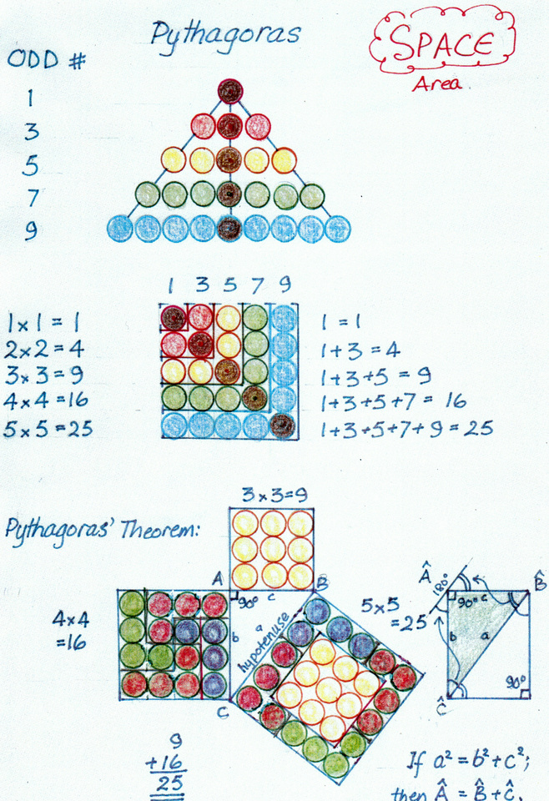
More next week - we will look at further examples of Pythagoras' Triangle Theorem; then the following week at Even numbers and time - in particular musical harmonic frequencies. RB
~~~

Musings 14 – NL25

Visual proofs of the Pythagorean Right Triangle Theorem
The challenge here is to show how the area in the 2 smaller squares can be transformed (by translation, reflection, rotation and shear) into the area of the largest square.
These appeal to visual and kinesthetic learning processes and activate the faculty of Imagination.
Example 1: by Translation - like going on a direct railroad to its new position, without any turning. The colours help you connect 'before' and 'after'. Note how the outside of the small squares become the inside of the larger square!!! The interior lines of the largest square are parallel to the exterior lines of the smaller squares, and vice versa. [The HYPOTENUSE is the longest side of a right-angled triangle, located directly opposite the 90 degree angle. It literally means "stretching under" [that is under the 'right-angle'.] If the Hypotenuse is the diameter of a semi-circle, lines from each end of the diameter drawn to any point on the semicircle will be at right angles.]
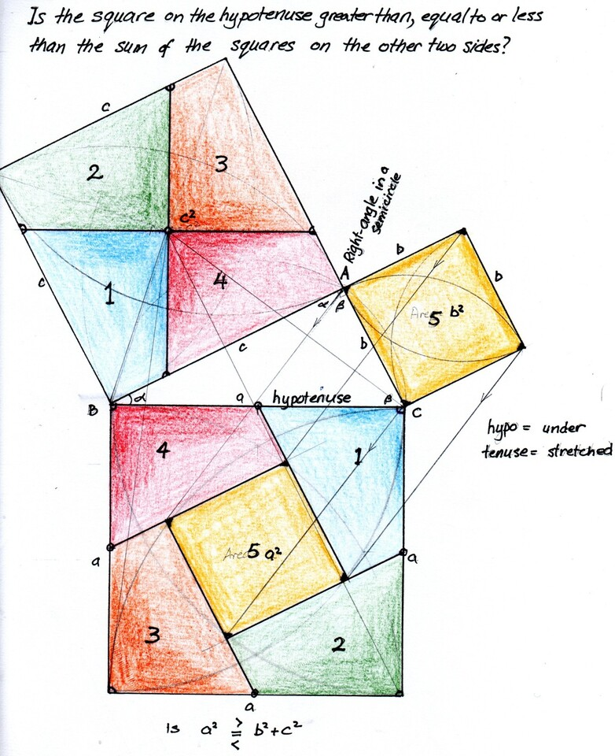
Example 2: Shear >> Rotation >> Shear
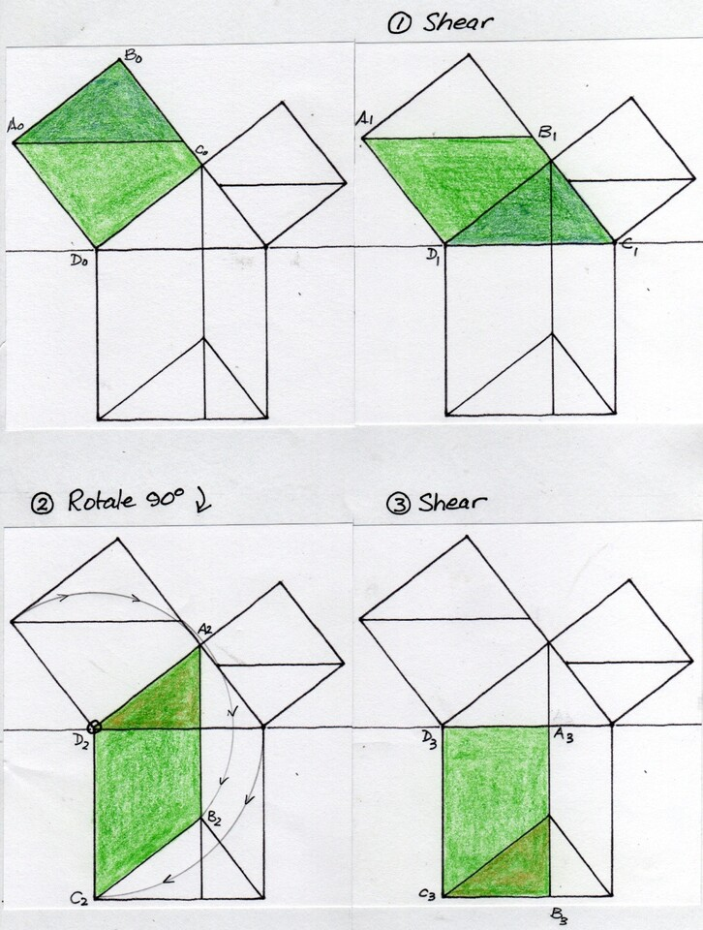
Example 3: Reflection >> Rotation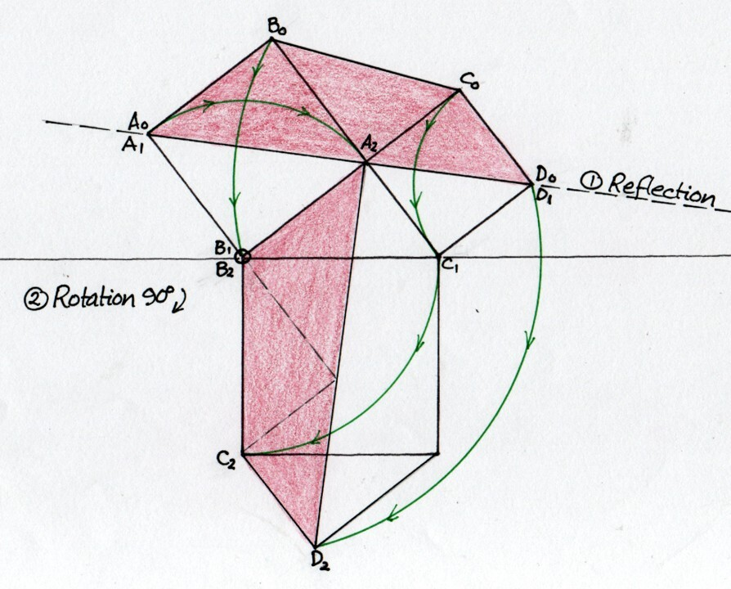
Example 4: Rearrangement by translation of the four identical, coloured right triangles so the remaining white space in the square field is the hypotenuse square in the first diagram or the two smaller squares in the second. Again, the colours help you follow what is happening.
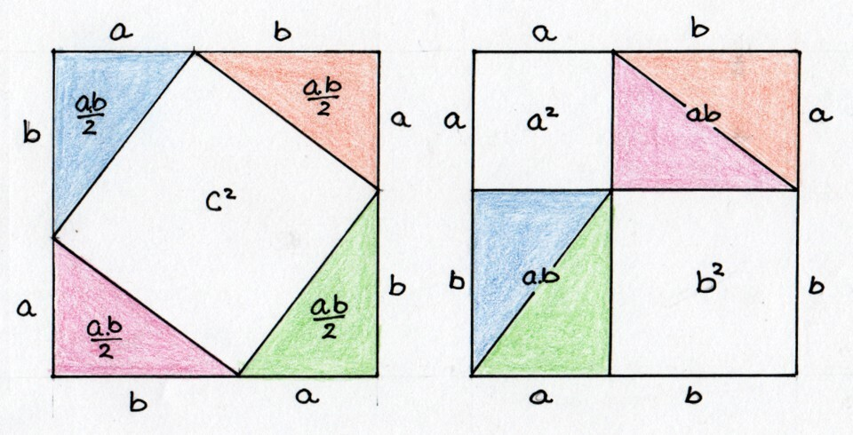
It was in the intense contemplation (a spiritual activity) of such geometrical proofs (of Pythagoras' Theorem) that Rudolf Steiner found much joy as a child, and wanted the children of the Waldorf School to experience the same in their Maths lessons. I hope that you can get a feeling for that inner activity.
More next week - we will look at Even numbers and time - in particular musical harmonic frequencies. RB
~~~

Musings 15 – NL28

Even Numbers and time - musical harmonic frequencies.
Here are some pebble patterns using Even numbers on the left and Odd numbers on the right, where a new one is introduced into the even pattern.
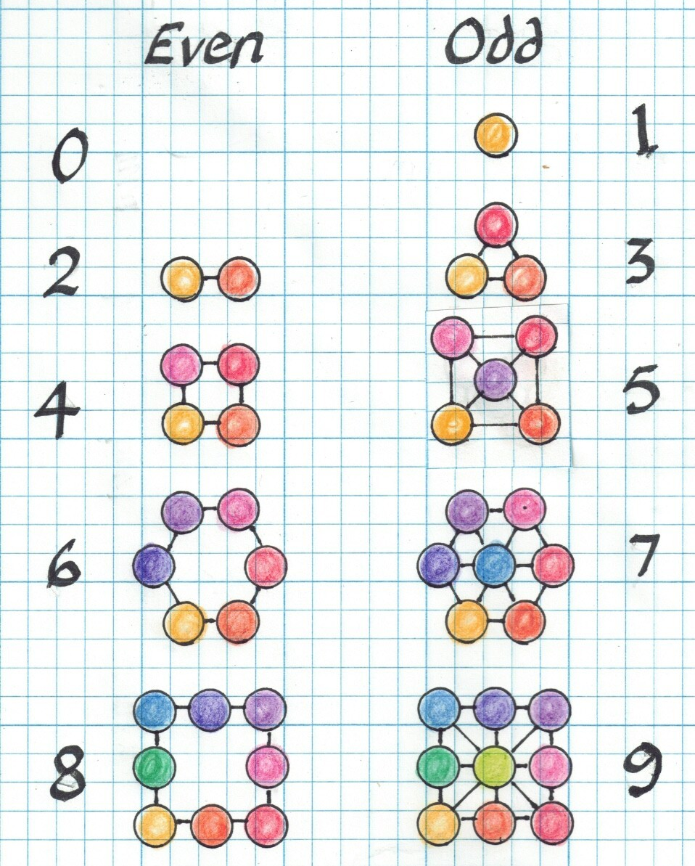
In the next picture, even-numbered lines of pebbles are formed into areas, building into larger areas.
The first diagram there is a rectangle 1 high by 2 wide; ratio 1:2;
next diagram the diagram has grown to 2 high by 3 wide; ratio 2:3;
next diagram the diagram has grown to 3 high by 4 wide; ratio 3:4;
next diagram the diagram has grown to 4 high by 5 wide; ratio 4:5;
next diagram the diagram has grown to 5 high by 6 wide; ratio 5:6.
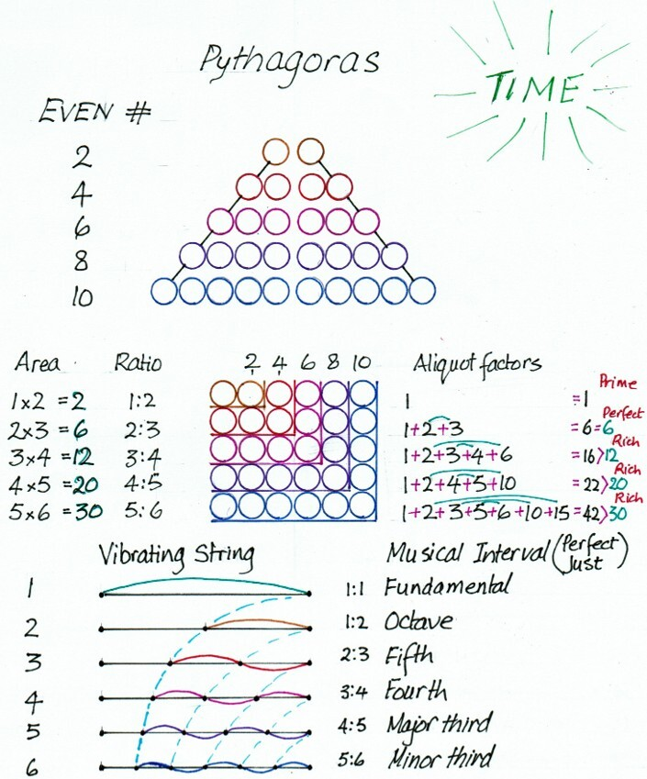
Pythagoras was interested in musical harmony and the ratios between lengths of vibrating strings.
When a solid, but flexible object, such as a taut string, is struck, shaken, plucked, bowed, etc., it is deformed slightly; this deflection pulls the neighbouring part with it, so that the deflection passes along like a wave. Then there is a correcting influence that pulls the stretched wire back to its original place, but it goes too far in the opposite direction.
This picture shows the alternating action as a travelling wave:
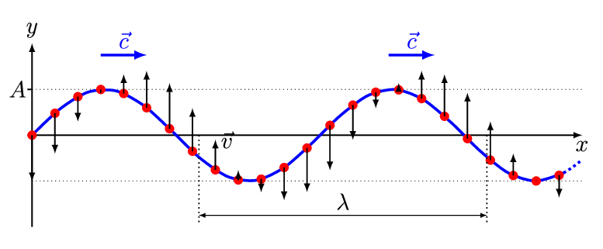
If many things are vibrating at the same time, each making a sound, then the result may be an unpleasant cacophony or a pleasing harmony which we have come to associate with music.
The energy of the blow or the bow is transformed into many different, simultaneous vibrations. The vibrating surfaces cause the adjacent air to move in sympathy, at the same frequency. This vibration is transmitted to our ears where we perceive it as a sound. It is only a sound when we hear it.
Musicians are very selective about what and how they set things vibrating.
Stringed Musical instruments, such as a violin, cello, guitar, lute, harpsichord and piano have taut strings or wires that are flexible and of even heaviness. They are “tuned” to vibrate in a particular, predominant frequency, stimulated by the bowing, plucking or striking. The horsehair violin and cello bow drags the string aside slightly, then releases it, initiating a lateral vibration.
One end of the vibrating string is attached to the hollow body of the instrument, which is caused to vibrate, thus stimulating the surrounding air which radiates to the air in our ears next to our eardrums, which mechanically transmit tiny vibrations to the liquid in the spiral cochlea (organised by our sentient body) where we perceive a tone, a musical sensation experienced by our sentient soul !!!
In a similar fashion the recorder, pipe, trombone, trumpet, oboe, bagpipes, etc. set enclosed lengths of air inside them into longitudinal vibration using the outbreath of the player. (scrutinise the back and forth movement of the red dot.)
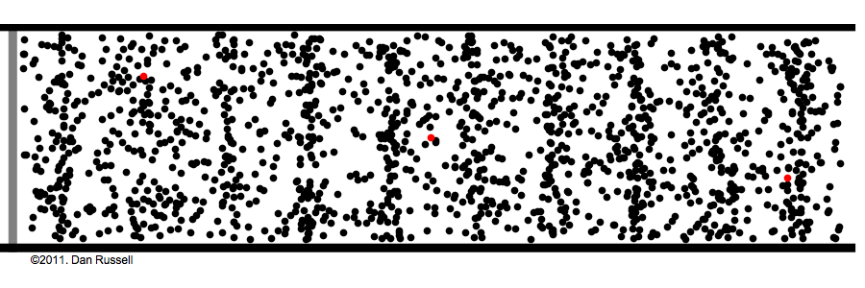
The pitch of the tone created by a string is determined by 3 factors.
Factor | Low-pitched tones | High-pitched tones | Method
Linear weight of string/wire | Heavier weight | Lighter weight | Design
Tension in string/wire | Slacker | Tauter | Tuning
Length from bridge to fret | Longer | Shorter | Playing
The length of a vibrating string can be altered by the player pressing the string on to a fret or the fingerboard.
A taut string/wire vibrates only in an exact, whole number of parts. When the part is large/long, then the tone is low.
When it is just a single part, it is called the fundamental tone, tonic or first harmonic.
When the string vibrates in two parts, the tone is called the second harmonic – it vibrates twice as fast as the tonic, that is at double the frequency.
similarly in 3 parts, at triple the frequency.

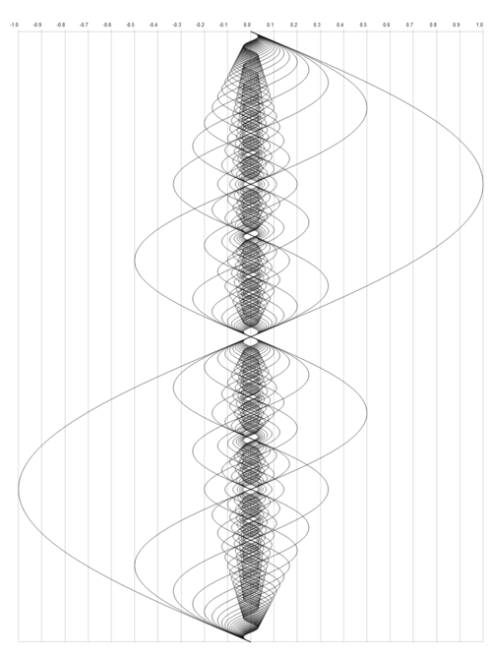
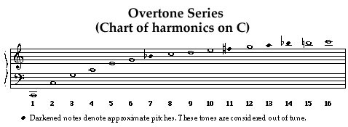
C C G C E G Bb C D E F G A Bb B C

- Resonance: When a guitar string or trumpet pipe vibrates, it resonates strongly at its primary pitch (the fundamental frequency) while simultaneously vibrating in fractional lengths (1/2, 1/3, 1/4) with less intensity.
- Instrument Uniqueness, Timbre: These smaller, hidden frequencies are called overtones, or harmonics. The specific blend and volume of these overtones determine the unique tone quality—or timbre—of every instrument.
- Watch this YouTube demonstration using a C-Horn it enables you to hear the sequence clearly
https://www.youtube.com/watch?v=Qzvp4_igvyw&t=13s
- Basis of Harmony: The first few overtones of a fundamental note outline the major triad (the fundamental [1st], 3rd, and 5th intervals) naturally. These natural intervals form the basis for most Western musical harmony.
When several tones are played at the same time on different strings they form a “chord”;
When tones are played in a sequence in time, they form a ‘melody’ – the jump from one tone to another is called an “Interval”.
- The Fundamental, 2nd, 4th, 8th and 16th harmonics form a very harmonious series: of Diapason (or Octave in modern terminology) interval series with the ratio 1:2. The Octave is the eighth note in a musical major scale.
- The interval between the 2nd and 3rd harmonics is the Diapente (or major Fifth) interval with the ratio 2:3.
- The interval between the 3rd and 4th harmonics is the major Fourth interval with the ratio 3:4.
- The interval between the 4th and 5th harmonics is the major Third interval with the ratio 4:5.
- The interval between the 5th and 6th harmonics is the minor Third interval with the ratio 5:6.
The Nodes are the parts of the string that twist a small angle, but do not move sideways or laterally.
The Antinodes are the parts of the string that move sideways but do not twist.
The form that they make is called a sine wave.
This scale was only replaced in 19th Century by the 12 semi-tone equal-tempered Octave (based on the 12th root of 2). More about this when we consider the power series.
More next week. RB

Musings 16 – NL29

Metamorphosis in the Waldorf Maths Curriculum reflects the growth of children.
Let us first look at the larger picture of our whole human life.
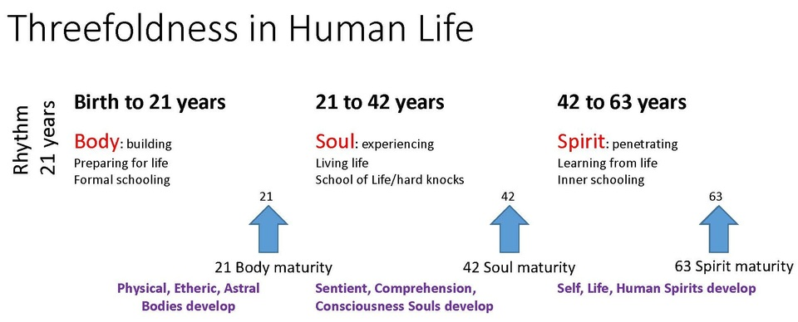
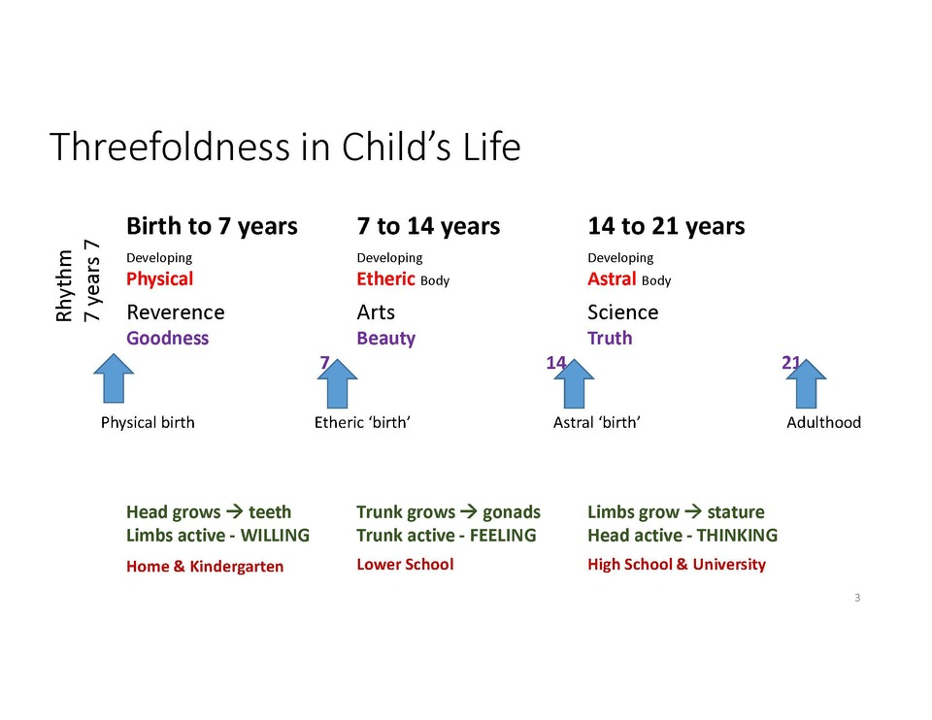
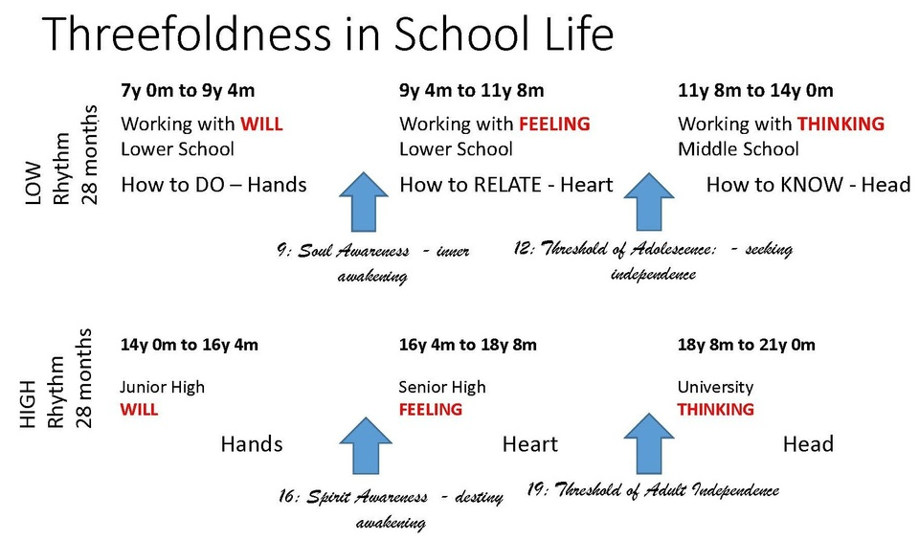
Using the Soul Forces in Mathematics:
•Will: OPERATION
creating and working with patterns and form;
counting discrete objects – determining quantity.
Writing numbers;
number operations [adding, subtracting, multiplying, etc.]; calculations.
Involving action, change.
•Feeling: RELATIONSHIP
rhythm and rhyme, the counting sequence,
relationships [equals =, larger >, smaller < than];
ordinal numbers – rank, position [first, second, etc.].
Involving judgment, comparison.
•Thinking: ESSENCE
the character of number, choice of symbols, concepts, cognition;
qualitative aspects.
Involving imagination, picturing.
~~~~~~~~~~~~
Math in Lower School
– first stage
•Before ninth year: active will – DOING.
Analysis - from whole to parts; awakening to the world;
from the basket to the apples; from the forest to the trees.
Building and changing patterns and shapes (form drawing).
Counting in whole numbers (discrete); up and down.
Expansion and contraction.
Creating a number system – what do you need?
Four operations: addition, subtraction, multiplication, division.
~~~~~
– second stage
Between nine and twelve: engaging feelings – experiencing RELATIONSHIPS; becoming aware of one's inner self that no one else can see.
Inner - outer; measurement – relating self to the world by measuring it against oneself or in terms of human activities or occupations. The basic quantities first measured were Length, Time, and Mass. [Head, Heart, Hand]
These quantities are continuous rather than "discrete" or 'exact'. The whole process of measurement is more analytical than synthetic.
<<Qualities such as energy and momentum, velocity and acceleration; sound and light intensity, magnetic and electric field intensity, and so on, only came to be considered after the Copernican Revolution at the beginning of the 5th Post-Atlantean period in the 15th Century.>>
Our Eyes in our Head see distance, the beginning and the end of an object: inch (thumb), hand [4], foot [12], yard [36]. fathom [2*36]. A mile came from 1,000 [mille] Roman marching steps (left-right) marked along roads of the Roman Empire, as milestones (did they rest every mile??)
Our Heart in our chest-body beats with rhythm (about every second), experiencing Time: second, minute [60], hour [60*60], day [24*60*60], etc.
Our Muscles in our Limbs (arms & legs) experience the inertia/weight of objects we move (actually accelerate): ounce, pound (lb) [16], stone [14*16] - I don't know if this was actually a mill-stone of fairy stories. {a sack (cwt) was 8 stones (about 50kg); a ton was 20 sacks} For tiny weights, grains of wheat/grain were used.
Measurement serves as a practical introduction to fractions - mostly not decimal fractions!
Factors: creating larger numbers from Primes by multiplying is more synthetic; whereas, finding the factors of a large number is an analytic process.
A million minus one = 1,000,000 - 1 = 999,999 = 3*333,333 = 3*3*111,111 = 3*3*3*37,037 = 3*3*3*7*5,291 = 3*3*3*7*11*481 = 3*3*3*7*11*13*37 {seven Prime factors} [ missing are 2, 5, 17, 19]
When I see '37', I wonder how did that get there? In Celsius, it is the healthy, internal temperature of the human body, of our blood ! !! Celsius 0°C for transition from frozen ice forming a cap over ponds, lakes and rivers protecting the aquatic therein from being frozen solid to the flowing water; and 100°C for transition from boiling water to powerful, venting steam that powered the great engines of the Industrial Revolution and the steam trains traversed Europe of that time.
It divides that space close to the Golden Ratio.
There are many mysteries in this world.
Multiplication of large numbers - becoming familiar with several algorithms {set of instructions} for multiplication, like that of Scottish Laird John Napier (inventor of logarithms); and one for the reverse process of long division. (topic for a further musing)
Rich, poor, prime and perfect - the four number temperaments.
Proportion, ratio, fraction, decimal.
Geometry of circles and polygons - dividing a circle first into 6 equal sectors, then into all portions up to 8.
3rd stage:
From twelve to fourteen: Puberty: experiencing thinking as an individual -- COGNITION, knowing that you know.
Perspective drawing - seeing the World from a particular, individual viewpoint; and learning the LAWS of Perspective, which enable a 2-dimensional drawing to appear 3-dimensional.
Pythagoras’ theorem; Proof: How do I know? Many parallel proofs using a variety of methods, based on 4 basic geometric transformations [translation, rotation, reflection, and shear].
Algebra: Finding the mathematical processes hidden within problems.
Astronomy: Movements and rhythms of our universe – adopting different viewpoints. The Earth spinning on its own axis, creating our experience of day and night; the orbital dance of the Sun and Earth, creating the year and its seasons. The orbital dance of Earth and Moon giving us the 4-week month from New Moon to Full and back to New.
Exploring the 3-dimensionality of the 5 Platonic solids and the metamorphosis of form between them
~~~
Over the next weeks, we will further some of the topics just mentioned here. If you have any comments or requests, please feel free to contact me. RB robin@bacchus.co.nz
~~~

Musings 17 – NL30

Growth by multiplication.
In Maths there several levels of intensity in the processes that expand or grow Number:
- Counting upwards: 1, 2, 3, 4, ....
- Addition: putting one pile on top of another: 3 + 5 = 8
- Multiplication: creating an area: 3 * 5 = 15
- Exponentiation: raising a base number to a power: (binary) 2¹⁰ = 1,024; (decimal) 10³ = 1,000 [kilo]. From Geometry we get the terms: square from 2*2 = 2² = 4, and cube from 2*2*2 = 2³ = 8
- Integral Calculus: used to find the area under a curved line, or the sum of a series of numbers.
We can perhaps get a picture 4 aspects of physical motion: distance travelled, d; time taken, t; speed or velocity of the vehicle, u initial speed, v final speed, the distance travelled every second; and the acceleration/deceleration (braking) causing change of speed during the journey, a.
Sir Isaac Newton devised equations of motion for steady acceleration, as when an object falls down under the influence of gravity:
Increase in speed: v-u = a*t; or v=u + a*t
Average speed: (u+v)/2
Distance travelled: d = t*(u+v)/2 = t*(u+u+a*t)/2 = u*t + a*t²/2
Calculus deals with more complicated situations when acceleration and braking is continally changing (eg. a racecourse)
There appears to be no upper limit to the size of numbers, or perhaps we should say it is 'undefined'. The term used for the largest number is Infinity. (without end, no finish)
It is interesting that the reverse processes that diminish or contract numbers reach thresholds, and a new type of number is born, but you need to be attentive to notice it rather than ignore it.
- Counting downwards: ....5, 4, 3, 2, 1, 0 zero, nothing, zilch, empty. A new idea - but why be interested in nothing, haven't you got something to do?
- Subtraction: 3 - 5 = -2, Here there is confusion because the same symbol is used for quite different purposes: first as 'minus', a symbol for the operation/activity of subtraction; the second as a symbol for 'negative', an adjective for a number positioned below zero in the number line. There is a whole world behind the mirror of 'zero'. ("Alice through the Looking Glass" was written by a mathematician.)
- Division: [rationalising] 3 ÷ 5 = 3/5. ' three-fifths', a fraction, a broken number. Now there is an 'infinity' of numbers just between 0 and 1. Here the relationship between the two numbers is important. Sometimes this is expressed as a 'ratio' 3:5 (the ratio of 3 to 5). This leads to another name for them as "Rational Numbers", implying that they are 'thinkable' numbers. [as long as it doesn't give you a headache!] More likely: when sharing a dividend among several people, each gets a ration.
- Extracting roots: The number, which when squared gives 4 is the square root of 4, namely 2. Similarly, the number, which when cubed gives 1,000 is the cubic root 1,000, namely 10. The symbol for this process is √. So, 2 = √4; and 10 = ³√1,000. In this case, the answers are integers (whole numbers). However, there are many numbers for which there is no rational number that works. Consider 2. What is √2?
Guess: let's try a first guess, a, for √2 of a = 3/2. Then a² = 3/2 * 3/2 = 9/4 >2, obviously too big by 1/4.
Let's try a second guess (a little smaller), b = 10/7. Then b² = 10/7 * 10/7 = 100/49 >2, only too big by 2/49. (Next guess, c = 100/71)
No matter how hard we try, we cannot find a ratio that works exactly. Perfection is not possible!
So, √2 is called irrational, literally 'unthinkable' or without reason. Another name is 'surd', - you can see the relation to absurd. Actually, surd means deaf or mute, speechless, without a voice. At best we can find a decimal approximation for these roots - a topic for a future musing.
5. Differential Calculus: used to find the slope or gradient of a line - expressed as the ratio of the change in height to the change of distance between two points on the line. To express the changing slope more accurately the points need to be drawn closer together, until they are almost touching! In the limit they become infinitely small or infinitesimal. The new concept here is the "limit" approaching zero.
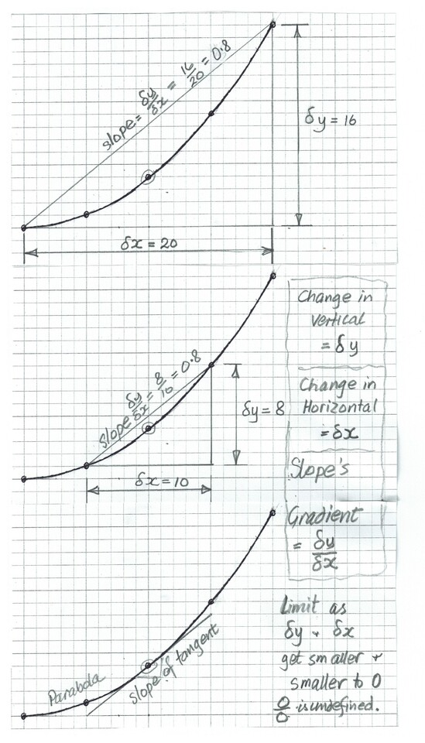
~~~
If you have any comments or requests, please feel free to contact me. RB robin@bacchus.co.nz
~~~

Musings 18 – NL36

Multiplication as 2 Dimensional pattern
Clock arithmetic
- The digits 0 to 9 are arranged into a clock face.
0-9
- The final digit of each times table forms a pattern.
- 1, 2, 3, 4, 5, 6, 7, 8, 9, 0
- 2, 4, 6, 8, 0, 2, 4, 6, 8, 0,
- 3, 6, 9, 2, 5, 8, 1, 4, 7, 0
- 4, 8, 2, 6, 0, 4, 8, 2, 6, 0
- 5, 0, 5, 0, 5, 0, 5, 0, 5, 0
- 6, 2, 8, 4, 0, 6, 2, 8, 4, 0
- 7, 4, 1, 8, 5, 2, 9, 6, 3, 0
- 8, 6, 4, 2, 0, 8, 6, 4, 2, 0
- 9, 8, 7, 6, 5, 4,3, 2, 1, 0
- E.g. for the 7x table:
0, 7, 14, 21, 28, 35, 42, 49, 56, 63, 70 or 07418529630 (the reverse of 3x table)
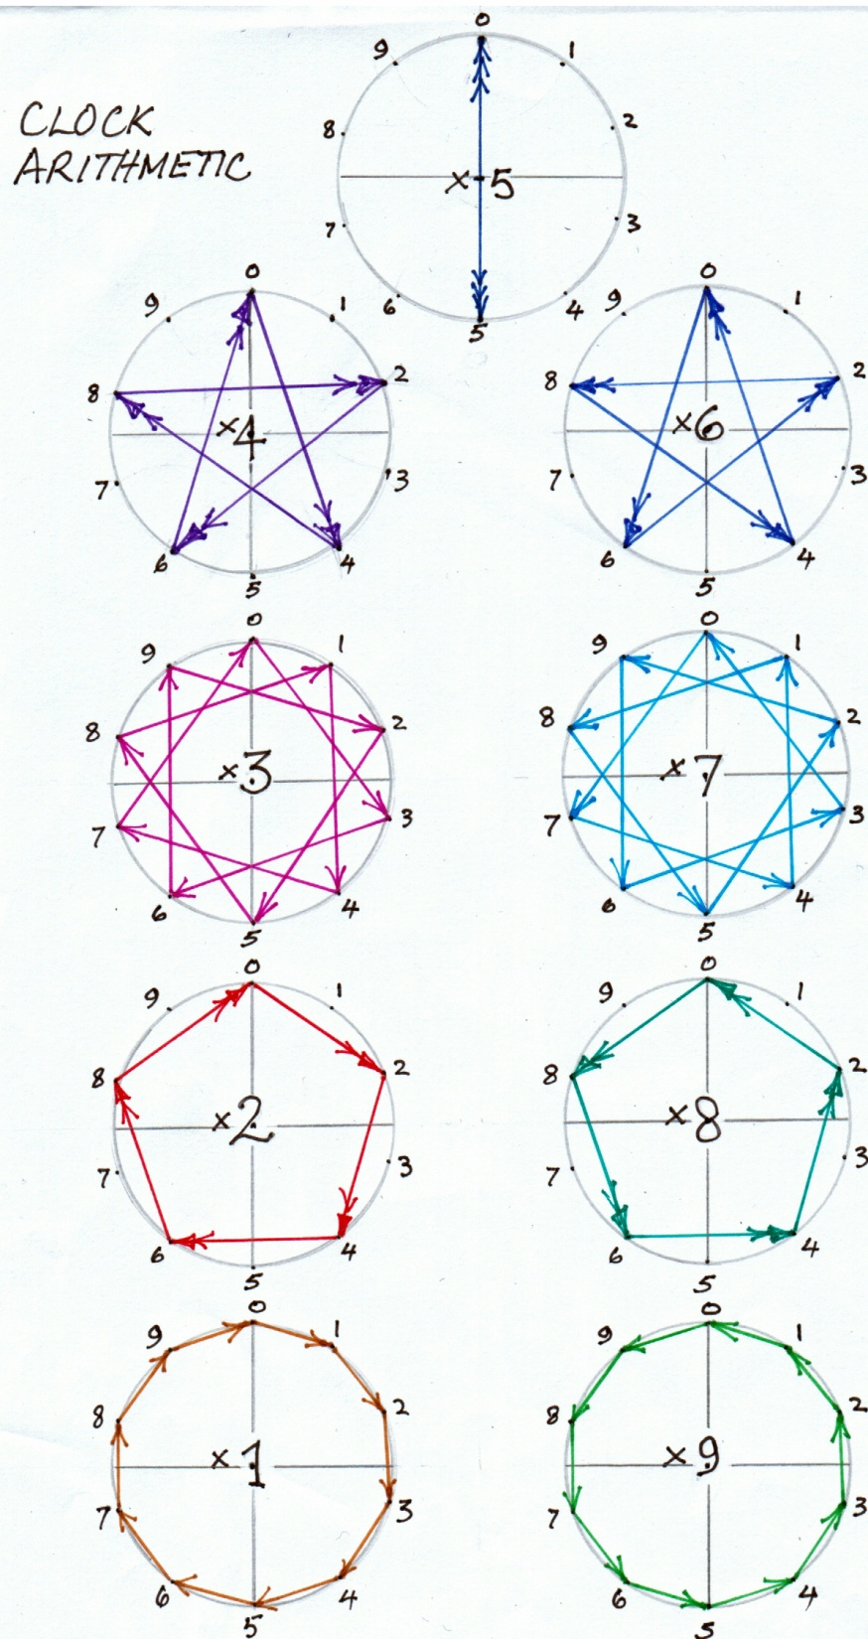
In Table or Lattice format, this pattern looks like this:
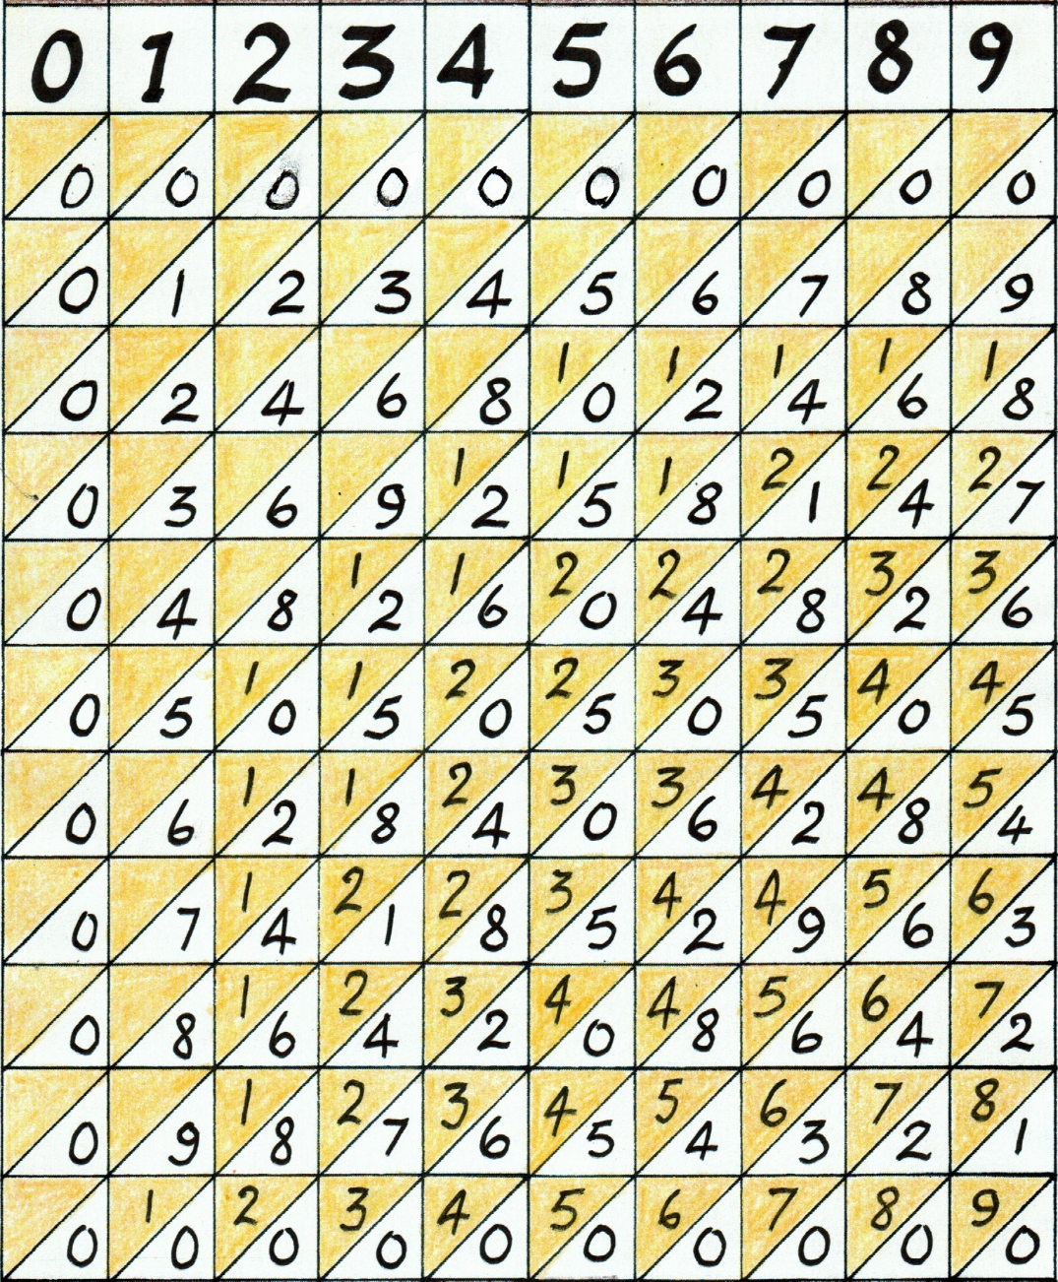
Note how the UNIT digit appears in the Lower Right sector of each small square, while the TENS digit appears in the Upper Left sector.

John Napier (1550–1617) was the 8th Laird of Merchiston (near Edinburgh) and the brilliant Scottish polymath best known for inventing logarithms.
Of local relevance, the city of Napier in Hawkes Bay is named after Sir Charles James Napier (1782–1853)—famous for his 1843 conquest of Sind in India—was a descendent of John Napier.

John Napier used strips of the lattice above to multiply very large numbers.
To see how this works, let us start with a 2-digit number, 87, multiplied by a single digit number, 8:
87 x 8 = 640 +56 = 6 / (4+5) / 6 = 6/9/6 = 696
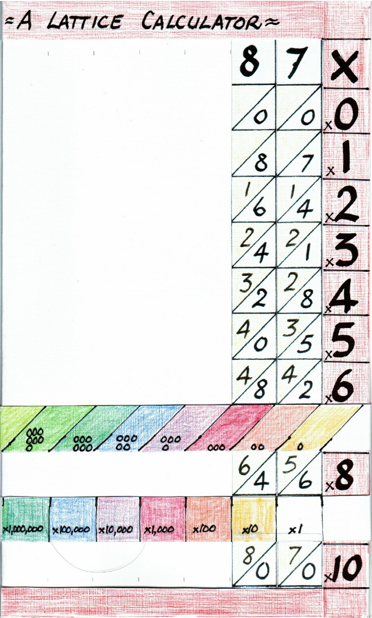

Now a 4-digit number, 4793, multiplied again by a single digit number, 7:
4,793 x 7 = 28,000 + 4,900 + 630 + 21
= 2 / (8+4) / (9+6) / (3+2) / 1
= 3/3/5/5/1
= 33,551

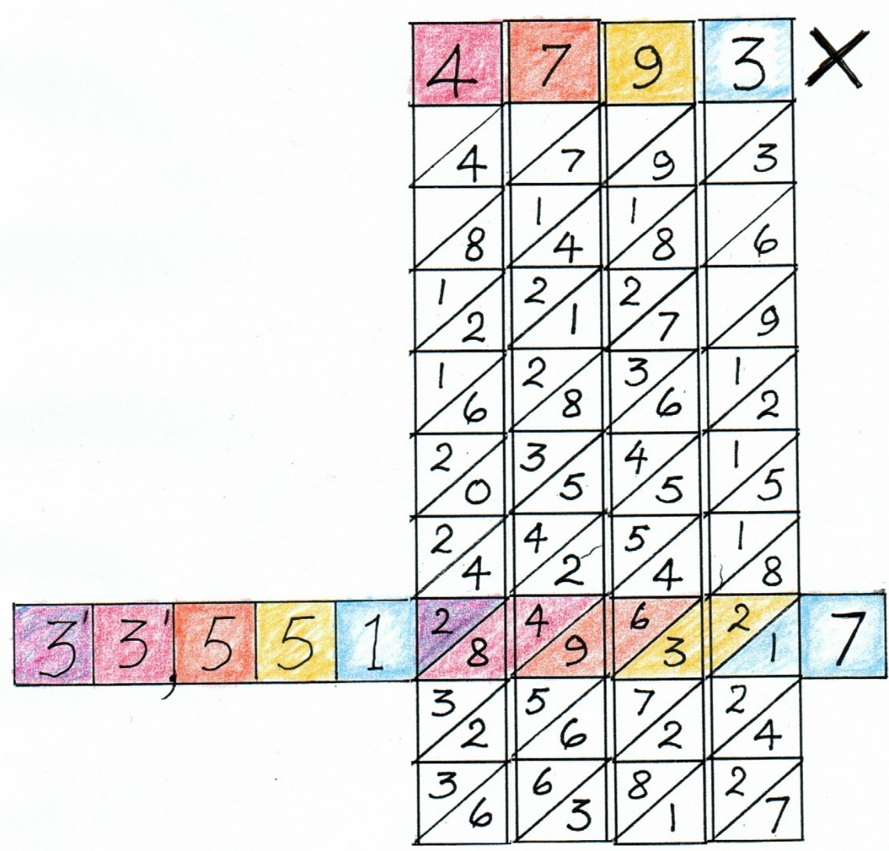
Now we will tackle multiplying a 4-digit number by a 3-digit number by stages, using colour to clarify.
2,459 x 367 = 902,453
First the lattice place with one number along the top and the second down the right side.
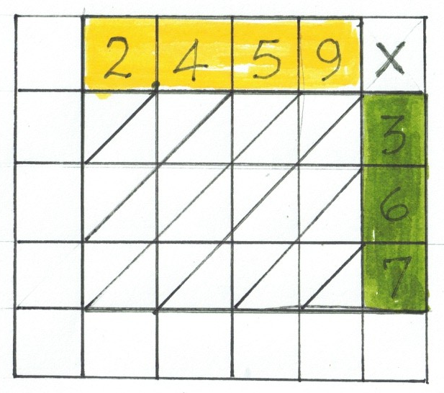
Now fill in the central block, using the product of the number above times on the number right, with the ten’s digit in the upper left half of the square.
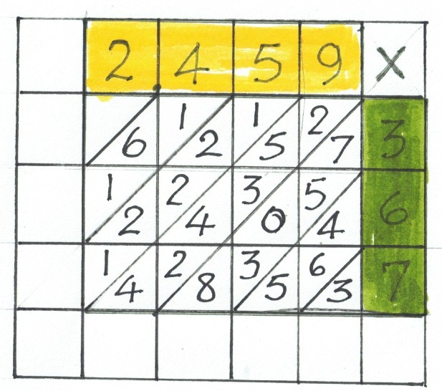
Now to get the tens and digit part of the answer. Add the numbers in the diagonal slide.
3 = 3
4+6+5 = 15 carry 1 to the next slide.

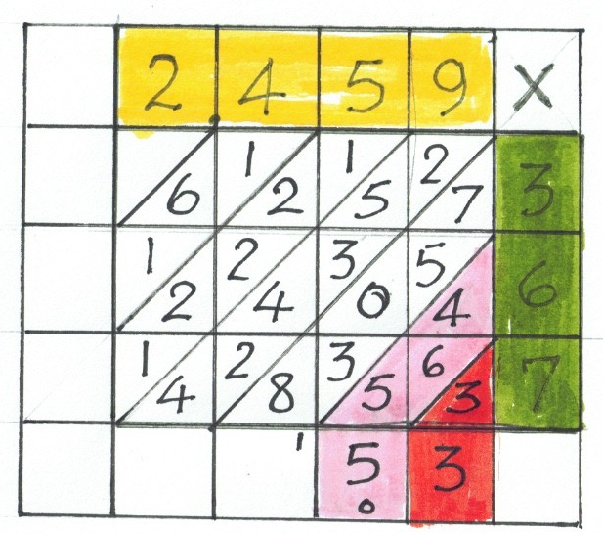
For the hundreds and thousands. 7+5+0+3+8+1=24; 2+5+3+4+2+4+2=22
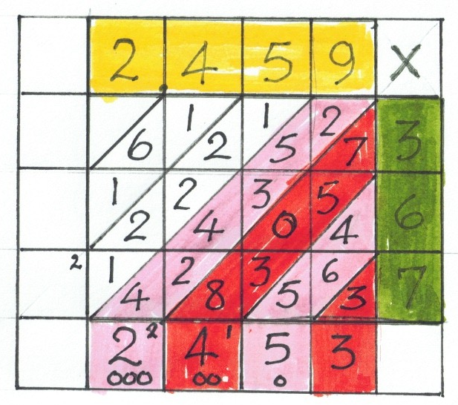
Completing the process.
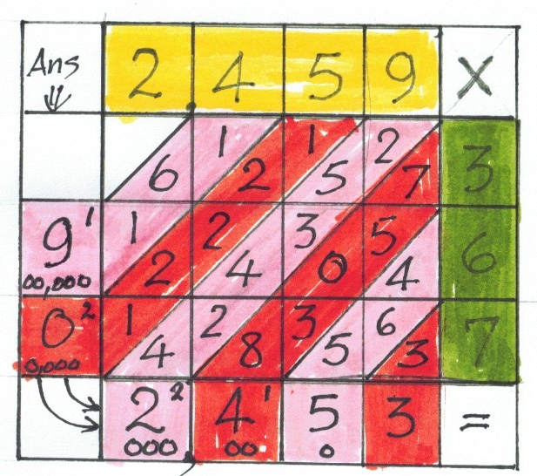
How does this compare with the way you were taught to write out long multiplication. Did you understand how it worked? Or just how to manipulate the numbers?
With Lattice Multiplication, everything is visible, (but still compact!) not hidden or carried mentally and so fully understandable, I believe. Once you understand it, the process can be condensed by carrying parts mentally, that us not writing it down
RB

