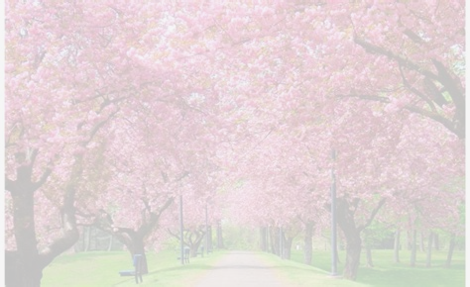
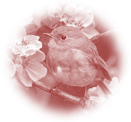
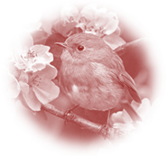
Spring Festival

Sunday 12th October 2025

at the Rudolf Steiner Centre, Hastings

Saturday, 11th Oct at 3pm – There will be a stirring of the Biodynamic Preparation 500 with Jen Speedy.

Sunday, 12th Oct at 3pm – a reading of Lecture 5 "The Working together of the Four Archangels" from ‘The Four Seasons and the Archangels’ with John Jackson

Sunday, 12th Oct at 7 pm – Social gathering over light refreshments in the Foyer

please bring a festive plate to share

7.30 pm – Festival Celebration:

A Festival of Enlightenment
O Man, know Yourself

Soul Calendar Verse 1- Easter Mood

When, out of world expanses,
The sun speaks to the human sense
And joyousness from out soul depths
With light unites, beholding,
Then, drawing forth from self’s enclosure,
Go thoughts to space’s farthest reaches
And dimly bind
Man’s inmost essence to the spirit’s being.
In the Archangel Raphael Imagination of the the Spring – when the renewal of our physical body and the physical world all around us takes place – Rudolf Steiner speaks of the danger of the counder-forces, Lucifer and Ahriman. At this time of the year, they are trying to gain power over us through the living lime in nature and in us...
Over time, year by year, they are gaining more access to our soul, and there is the danger of us losing our humanity through their temptation and deception, and becoming more and more chained to the physical, purely material world.
But we have the opportunity also, of finding ourselves in our spiritual humanity at this time – through the healing forces of Raphael-Christ for body and soul – to be prepared for the unfolding of the summer mystery.

The evening will open with Music by our CHB friends, Bob and Jenny. After the welcome, John Jackson will speak the Soul Calendar verse 1 – Easter Mood; and we will hear a spring poem spoken by Robyn Hewetson. We will then all move together in Eurythmy with John Allison.

Initiation in the desert: ‘The Prophet’ by Alexandre Pushkin, will be spoken by the Festival Chorus, followed by us all singing verse 1 from Julian’s Soul Calendar Rounds, together, led by Bob Cross.

The Counter Forces: we will hear Julian’s music of Benedictus’ verse from the Higher Devachan, sung by a small Festival Singers’ Group; and Leslie Wait will give the Festival Address, about the counter forces we will experience in Scene 4 from Rudolf Steiner’s ‘Portal of Initiation’, presented by students and associates of the ‘Spirit of the Word School’. To conclude the evening we will hear Benedictus’ verse sung again.

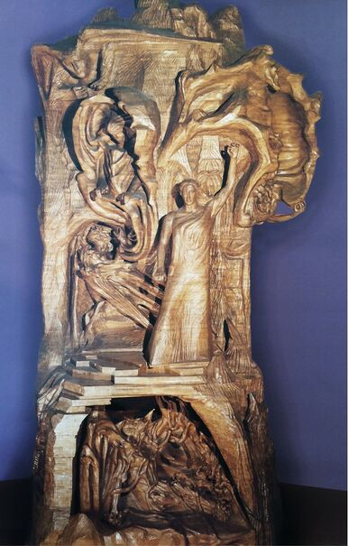
About the sculpture of the Representative of Mankind by Rudolf Steiner –
An image for the inner dynamic in the spring-time

The statue of the Representative of Mankind, the Christ Jesus standing between the adversary powers, was created by Rudolf Steiner despite his many other responsibilities, during a period of ten years together with Edith Maryon and a number of artist colleagues. “It was my task in Dornach to place this important Sculptural Group in the Building for the School of Spiritual Science” he said, indicating its dominant central position on the stage at the eastern end. This was to be understood as the crowning feature of the First Goetheanum and indeed from the beginning, also the School of Spiritual Science. The Sculpture escaped the terrible fire which destroyed the double cupola building during the Sylvester night of 1922/23. Rudolf Steiner however continued to carve on the main figure after the death of Edith Maryon until he withdrew to his own sickbed. The Statue of the Representative of Mankind belonged to what was most dear to Rudolf Steiner and is inseparable from the founding of the new Christian Mysteries bound to the future tasks of the Goetheanum.
This Statue and its accompanying models represent the Christological kernel of the Dornach School of Spiritual Science.
Peter Selg

