25 June 2026


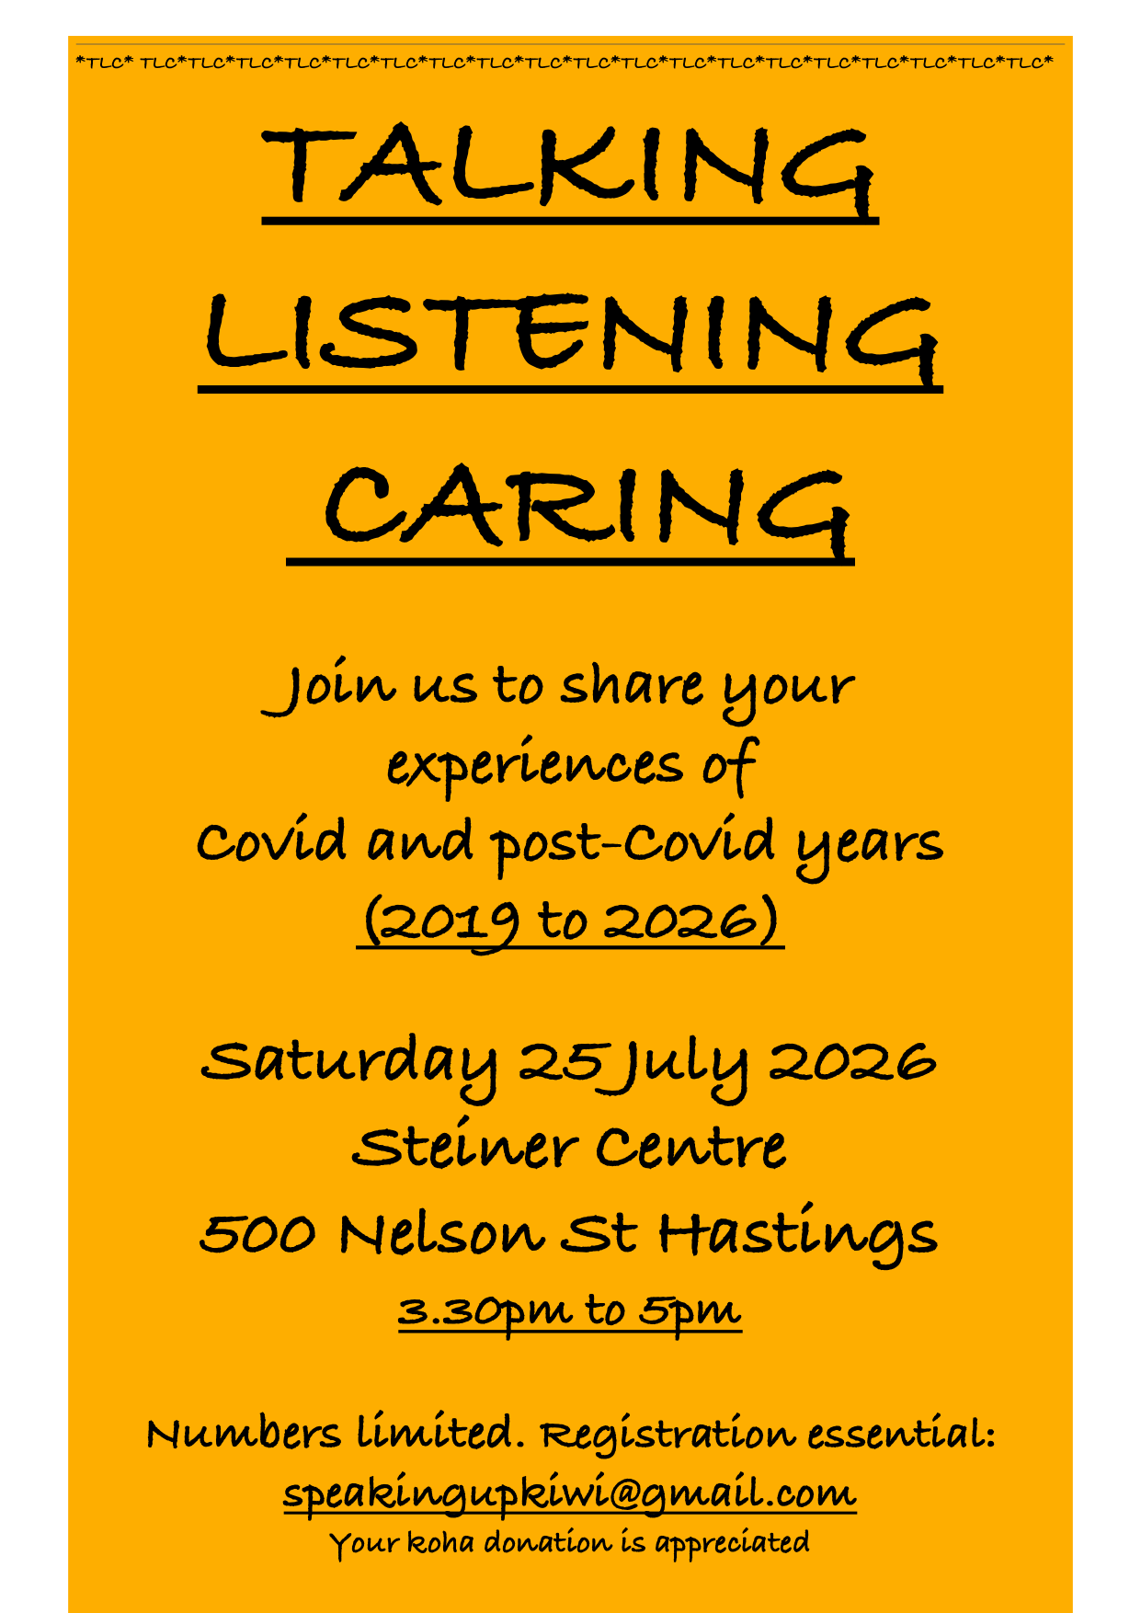
Concordia Health
500 Nelson St North
Hastings

Dear Friends
One morning I got the nudge to create a space for my friends to speak about their experiences during the Covid Years (2019 - 2026). The ripples of these years continue to go outward into ourselves, families and communities. We learnt so much about ourselves during those years, and some of us activated our will to go forward, no matter what. Then, the nudge came to delay a month, so here is the new date.

Please join me on Saturday 25 July 2026, 3.30pm to 5pm, at Rudolf Steiner Centre, 500 Nelson St North, Hastings. We will gather in small groups and speak about these times. You will be given a choice to join the MIQ, Lockdown, Mandates or Other group. You will be given 6 minutes to speak from your heart, from your experiences. When we come back together, your collective wisdom will be shared with the whole group, according to what your group deems is acceptable.
I look forward to seeing you soon.
Please RSVP to my email speakingupkiwi@gmail.com.
Warm regards
Angela Hair

